**TrustCheck**  
A Chrome Extension for Evaluating Online Product Description Legitimacy

*Sriram B. Swami – 22BCE5103*

*Meghna Varma – 22BCE5085*

*AO Navin Kumar – 22BCE1020*

*Aakash K – 22BCE5157*

Under the mentorship of Dr. Priyaadharshini M,

School of Computer Science and Engineering (SCOPE),

VIT Chennai

| Objectives

The primary objective of our project is to assess the legitimacy of the product descriptions posted on e-commerce websites such as Amazon by comparing them with an overall aggregate of actual customer reviews in an aspect-based fashion. The system utilizes web scraping and aspect-based sentiment analysis to try to check whether the product descriptions accurately reflect the experiences and expectations of customers. In doing so, this project aims for:

* **Increase in Customer Satisfaction:** Help customers know which products would meet their expectations, saving them valuable time spent going through comments, allowing for informed purchasing decisions and increasing their satisfaction with their experience.
* **Decrease in False Advertisements:** Improve transparency among sellers by flagging products that failed to meet their description standards upon purchase.
* **Reduction in Product Returns:** Minimize misinformed purchases, hence reducing overall product returns that were due to dissatisfaction, benefitting the time of the customers as well as the sellers.
* **Seller-Buyer Trust Factor:** Generate a degree of trust among sellers and buyers with improved transparency, pushing towards a more reliable and pleasing marketplace.

Benefitting customers as well as legitimate sellers, we believe our solution pushes for a more credible marketplace and allows for a happier experience for those shopping on e-commerce websites.

| List of Modules

1. Web scraping module

2. API Gateway Module

3. Data Orchestrator Module

4. Preprocessing module

5. NLP Module

| Module Description

1. **Web scraping module**

This contains the browser extension which makes up the frontend ui. The browser extension takes an optional “aspect” (eg: if we’re considering a smartphone, viable aspects could be battery-life, camera quality, durability etc.) as its parameter which it bases the sentiment analysis off of. If no aspect is provided, it sentiment analyses all available reviews.

It then scrapes the reviews, formats them into json format and then sends them to the lambda function using AWS API Gateway.

This is hosted on an AWS EC2 Server to ensure resources are allocated efficiently, expanding during peak times and contracting during periods of low activity, thereby optimizing costs while maintaining performance.

1. **API Gateway Module**

We use an HTTP gateway which connects directly to the lambda function hosting the endpoint.

API Gateway acts as a secure endpoint to transmit data to the lambda function. It supports **SSL/TLS policies** to secure communications between clients and the API Gateway. These policies enforce encrypted data transmission, ensuring the confidentiality of data exchanged.

API gateway also enforces the integrity of data, ensuring that the transmitted data consists of well-formed JSON payloads and contains the required fields.

1. **Data Orchestrator module**

This module is implemented using the lambda function which hosts the SageMaker model’s endpoint. It acts as a backend processor bridging the gap between API gateway and SageMaker. It also handles on demand scaling, processing requests efficiently.

It routes the JSON input from the API gateway, sends the data to SageMaker and returns the processed results back to the browser extension. A timeout mechanism is also implemented, and the limit is set to 5 minutes to manage errors, such as model timeouts or invalid inputs. If an output is not received within this time period, the request is terminated, and the next query is executed.

An environment variable is used to map the endpoint name to a key, ensuring data abstraction and security. Policies and permissions are also configured to allow lambda to access the endpoint.

1. **Preprocessing module**

Training data stored in the s3 bucket is retrieved for preprocessing using the python library: boto3. Various preprocessing techniques are implemented to clean the data removing non-essential characters like emojis and special characters. Further reviews written in languages other than English, are discarded to remove dataset noise.

Then tokenization is performed next, splitting complex sentences into individual words or sub-words. Sequences of varying lengths are padded to standardise their lengths as the model requires uniform length sequences.

Stop-word removal is also applied, removing connector words which typically don’t add much meaning to the sentence like “is”, “the”, “a” etc. This pipeline ensures that the model is trained on clean and consistent data.

1. **NLP Module**

When it comes to training, the data is split in an 80:20 ratio with 80% making up the train set and 20% making up the test set.

Model structure is created using a simpleRNN as the base model to capture sequential dependencies in the text. Further, embedding, flatten and dense layers are also added sequentially to convert words to dense vectors, converting high dimensional data to lower dimensional data or dimensionality reduction and to convert data into the desired output format (Either -1,0 or 1 where -1 corresponds to negative, 0 to neutral and 1 to positive sentiment).

A label encoder is then used to map the obtained integer to its respective sentiment, printing along with it a confidence score, indicating the model’s certainty of its answer.

The model is compiled using the Adam optimizer and categorical cross entropy is the preferred loss function as we are dealing with multiple output classes. We, then fit the data on the train set and train it for 10 epochs with a batch size of 128.

Once the model is trained, it is then tested and then deployed onto an ml.m5.xlarge instance.

| Architecture

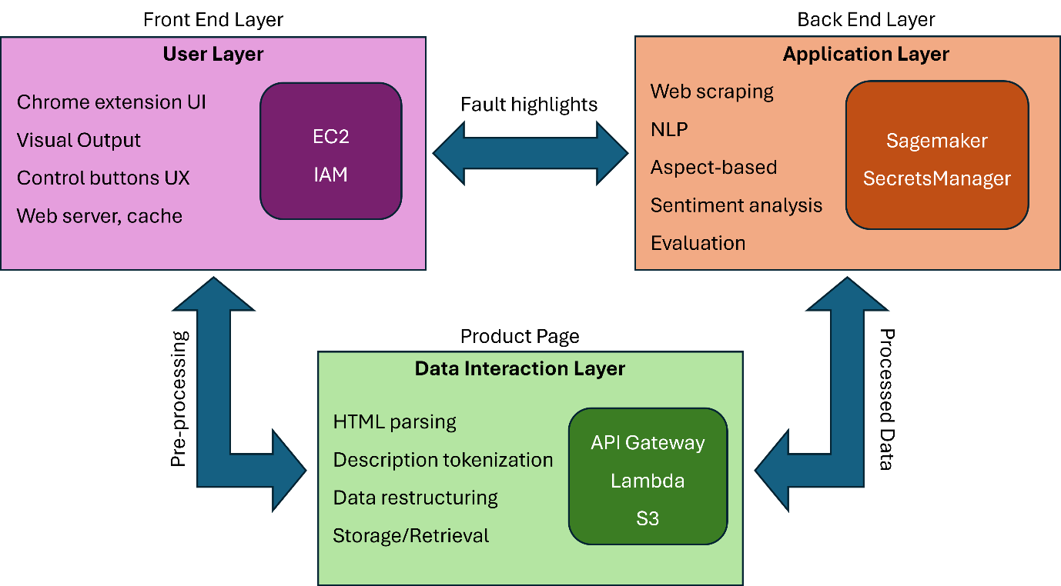

Figure 1: Architecture Layout

**Overview of System Layers**

The architecture uses a tri-layered model that utilizes modularity to allow for distribution of functionality. The three primary layers are User Layer, Application Layer, and Data Interaction Layer. Each layer is designed to handle relevant tasks, improving scalability and performance.

**1. Front End Layer (User Layer)**

The User Layer focuses on providing an intuitive interface for users and ensures seamless interaction with the system. This includes:

* **Chrome Extension UI**: The main point of interaction for users to analyze product descriptions. Users can activate functionalities, view results, and get visual insights directly on product pages.
* **Visual Output**: Displays the processed results, highlighting mismatches or flaws in the product description.
* **Control Buttons and UX**: Interactive controls allow users to initiate analysis and customize settings.
* **Web Server & Cache**:
  + **AWS EC2**: Hosts the backend of the Chrome extension, providing computing power and caching for low-latency responses.
  + **AWS IAM**: Manages access control, ensuring secure communication between different AWS services.

**2. Back End Layer (Application Layer)**

The Application Layer is responsible for the core computational tasks such as data analysis and NLP model inference. It includes:

* **Web Scraping**: Extracts product descriptions and customer reviews from the e-commerce platform.
* **NLP and Sentiment Analysis**: Processes the extracted data to identify aspects, perform sentiment analysis, and compare customer sentiment with the product description.
* **Evaluation**: Determines whether the product description aligns with customer feedback.
* **AWS SageMaker**:
  + Used for training, fine-tuning, and hosting the NLP model that performs tasks such as aspect-based sentiment analysis.
* **AWS Secrets Manager**:
  + Securely manages sensitive information like API keys and credentials required for accessing web scraping APIs and AWS resources.

**3. Data Interaction Layer**

This Layer acts as a bridge to fill the gap between raw data and the application layer. It prepares data for analysis and manages communication with the user interface. This layer includes:

* **HTML Parsing**: Extracts the necessary textual data (product descriptions and reviews) from the e-commerce product page.
* **Description Tokenization**: Splits the text into tokens for easier processing by the NLP model.
* **Data Restructuring**: Converts unstructured data into a structured format for further analysis.
* **Storage and Retrieval**:
  + **AWS API Gateway**: Facilitates the communication between the Chrome extension and backend services by handling API requests and responses.
  + **AWS Lambda**: Implements serverless computing for tasks such as data preprocessing, tokenization, and restructuring. It processes data in real-time
  + **AWS S3**: Provides scalable storage for intermediate results, processed datasets, or logs, ensuring persistence and easy retrieval of data.

**End - to - End Workflow**

1. **User Initiation**: Users interact with the Chrome extension UI to analyse the product description.
2. **Data Collection**: HTML parsing is triggered via the **Data Interaction Layer**, scraping product descriptions and customer reviews.
3. **Preprocessing**: Tokenization and data structuring occur using **AWS Lambda**, with temporary storage in **AWS S3**.
4. **Analysis**:
   * Data is passed to the **Application Layer**, where **AWS SageMaker** hosts the fine-tuned NLP model.
   * The model processes the data, performs sentiment analysis, and evaluates alignment between customer sentiment and the product description.
5. **Results**: The results are sent back to the Chrome extension via **API Gateway** and presented to the user in the UI.
6. **Secure Access**: All interactions are secured by **AWS IAM**, and sensitive data is protected by **AWS Secrets Manager**.

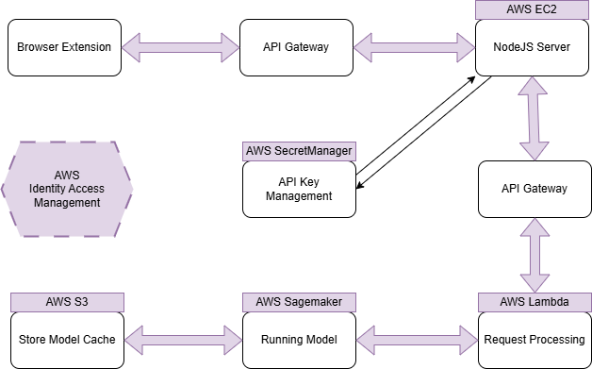

Figure 2: Architecture Workflow

**Salient Features**

* **Scalability**: The use of **AWS Lambda** and **SageMaker** allows the system to scale efficiently with increased user demand.
* **Cost-Effectiveness**: Serverless computing in **AWS Lambda** ensures cost optimization, while **S3** provides affordable storage options.
* **Security**: **IAM** and **Secrets Manager** ensure secure access and data handling across the architecture.
* **Flexibility**: The modular design allows individual layers to be updated or replaced without affecting the entire system.

| Individual Contribution

**Sriram:** Web scraping, NLP, Preprocessing, Sentiment analysis

**Meghna:** Tokenization, Model training, Preprocessing

**Navin:** Front End, UI/UX, Gateway Integration

**Aakash:** Backend, Data extraction, Gateway Integration

All 4 of us have contributed and committed to the project and have seen it through from start to finish. While the areas of expertise have been mentioned above, when it comes to the using the Amazon Web Services and deploying our project, all 4 of us worked on it together.

| AWS Services Used

1. **AWS EC2 (Elastic Cloud Compute):** AWS EC2 is used to provide scalable virtual servers in the cloud for running applications and workloads. We are using this service to host our dynamic browser extension (as a web server).
2. **AWS IAM (Identity and Access Management):** Manages user access and permissions in AWS. It helps securely control who can access resources and what actions they can perform, using fine-grained permissions and policies.
3. **AWS API Gateway:** AWS API Gateway is used to create, publish, and manage APIs that allow applications to securely communicate with backend services. We are using this service to create a entry way or access point to the backend services from the front end.
4. **AWS Lambda:** AWS Lambda is used to run code in response to events without provisioning or managing servers, enabling serverless computing. We are using this service as a HTML parser and preprocessor to extract required information.
5. **AWS SageMaker:** AWS SageMaker is used to build, train, and deploy machine learning models at scale in the cloud. We are using this service to train and deploy our own NLP model to perform aspect-based sentiment analysis.
6. **AWS Secrets Manager:** AWS Secrets Manager securely stores and manages sensitive information like API keys and database credentials. It provides automatic rotation, encryption, and easy retrieval through API calls, reducing the risk of exposing secrets in code. It’s ideal for secure and streamlined secret management in AWS environments.
7. **AWS S3 (Simple Storage Service):** AWS S3 (Simple Storage Service) is a scalable cloud storage solution for storing and retrieving data. It’s ideal for backups, data archiving, and serving files, offering secure, durable, and highly available storage in the cloud.

| Output Screenshots

* Browser Extension
  + UI of the extension



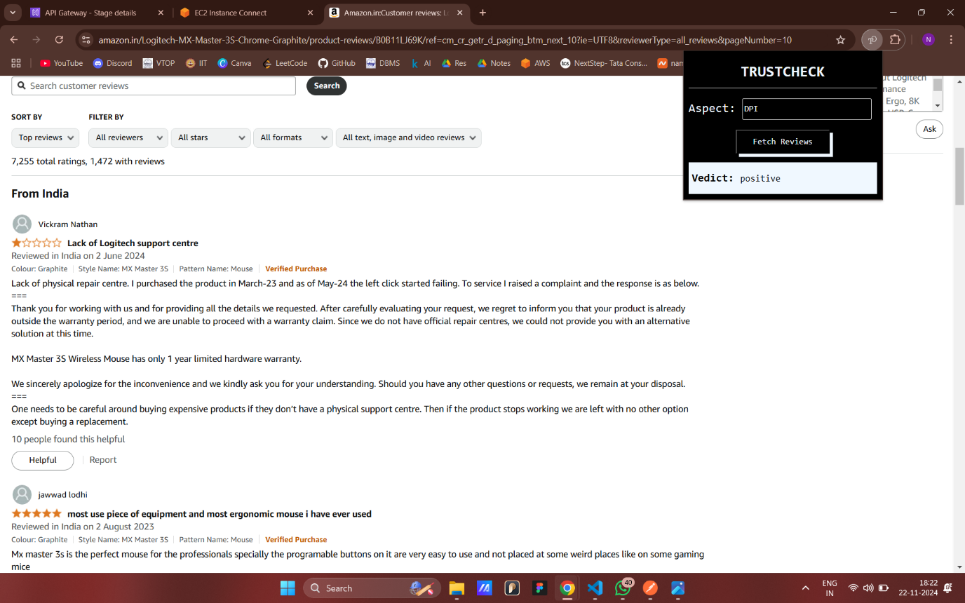

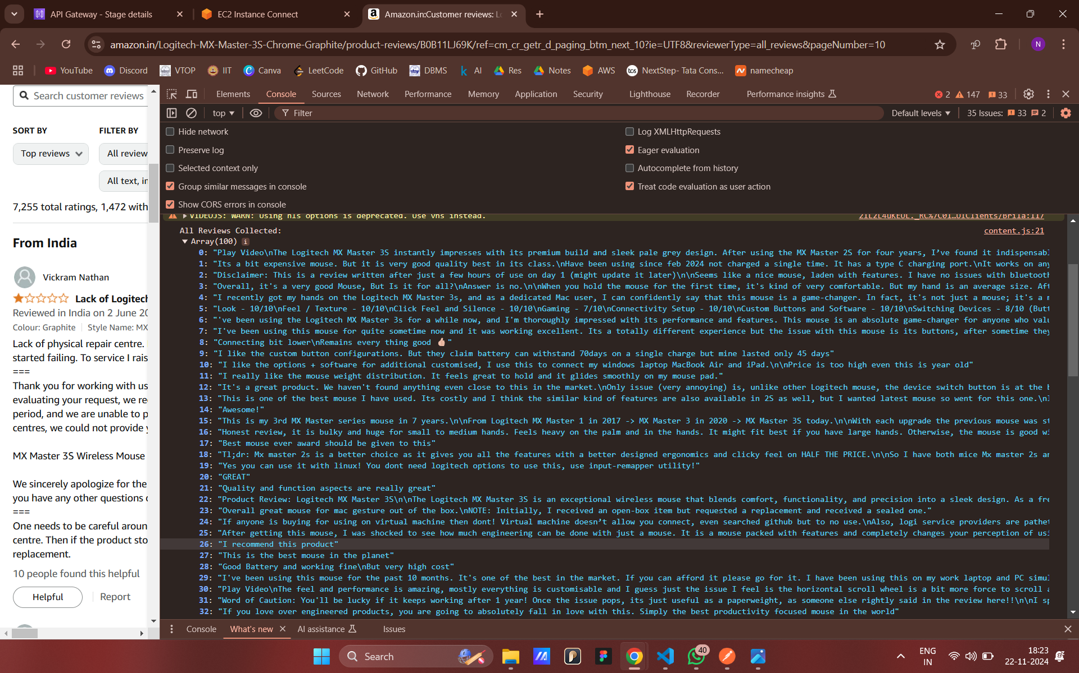

* Backend Server
  + EC2

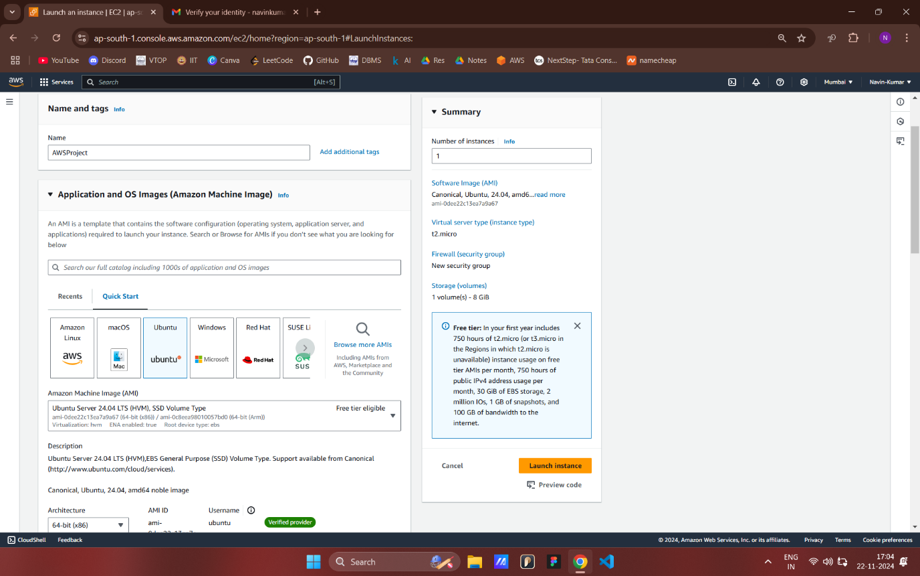

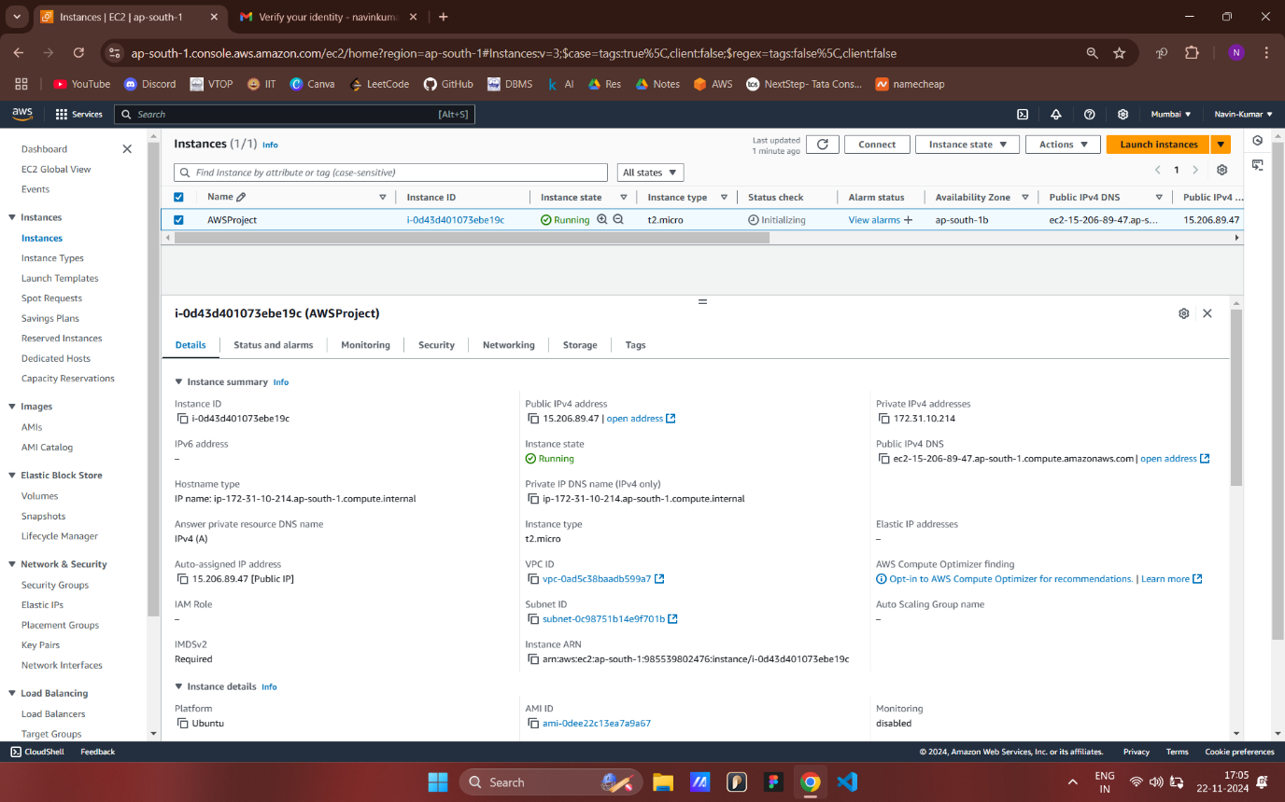

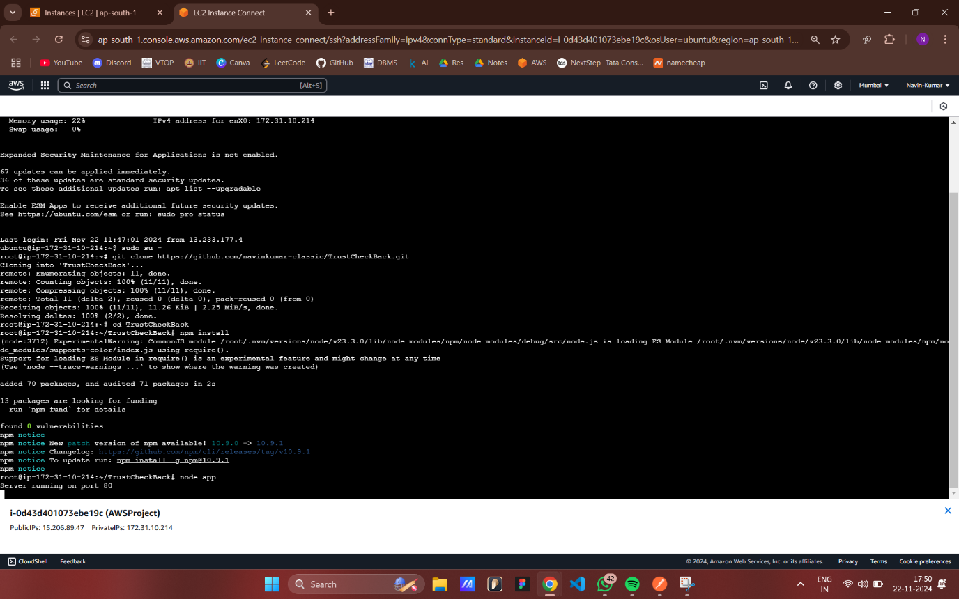

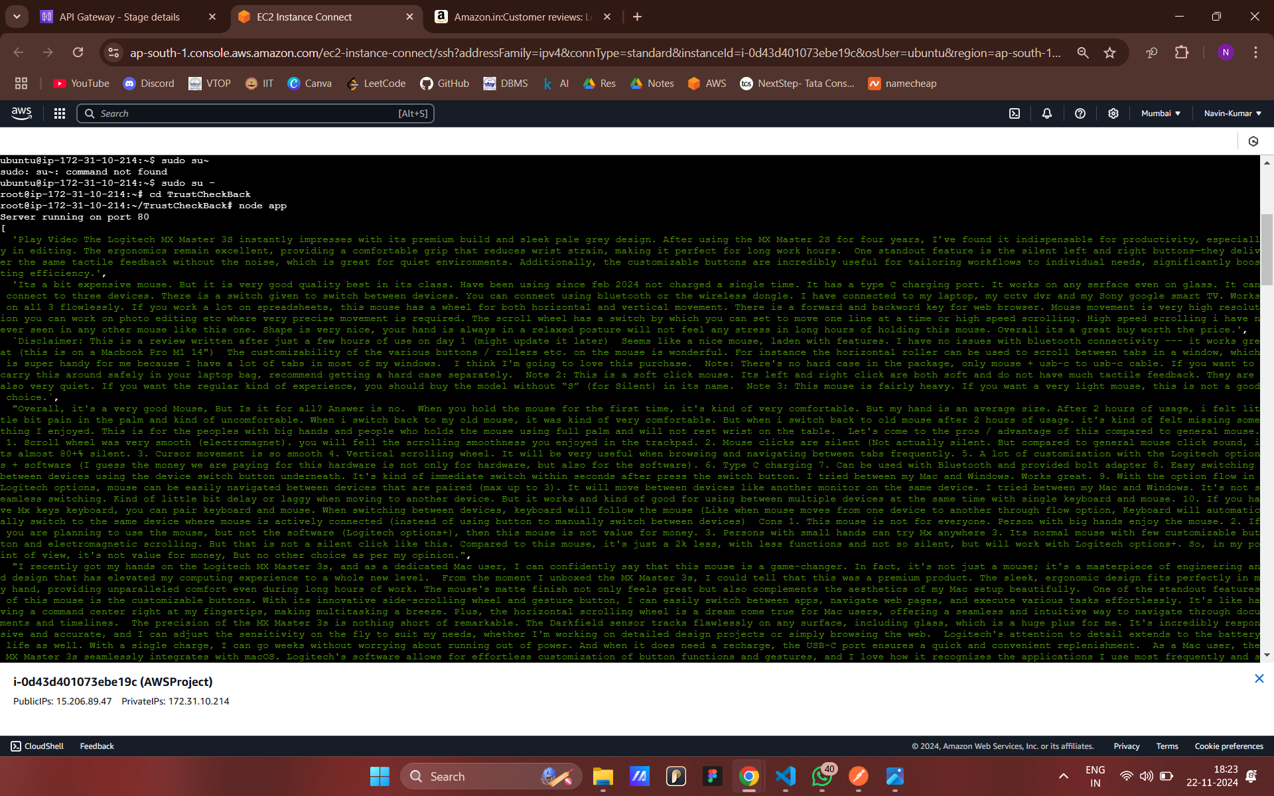

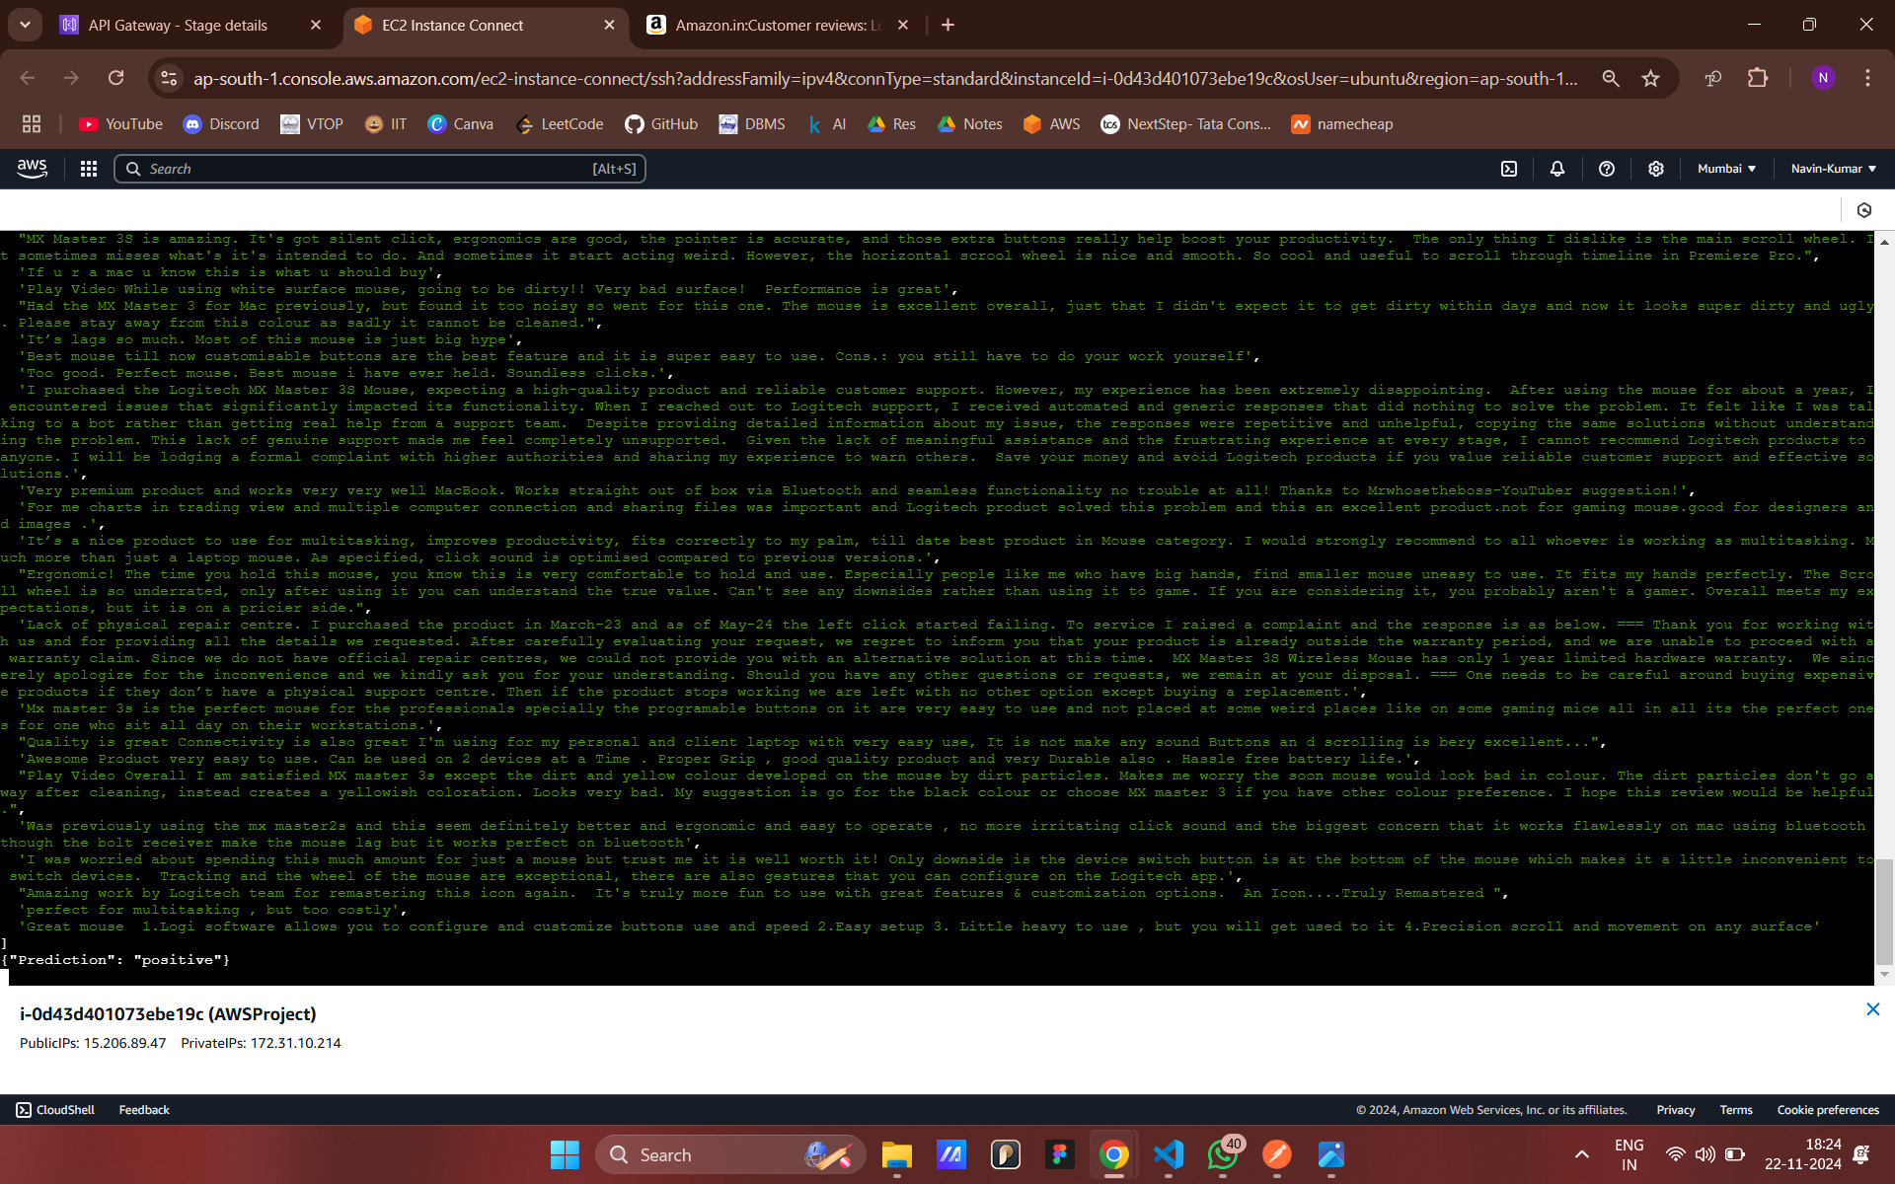

* + AWS Secret Manager

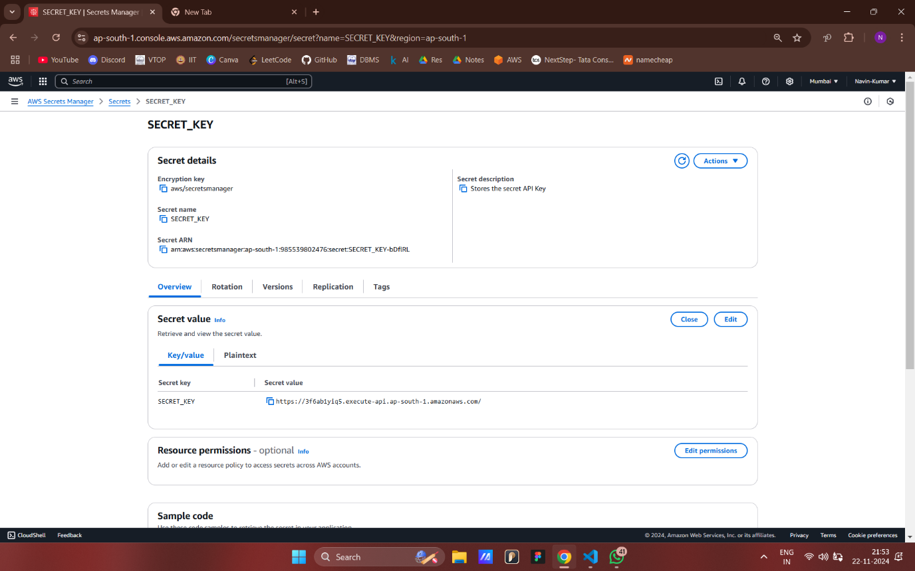

* + AWS API Gateway

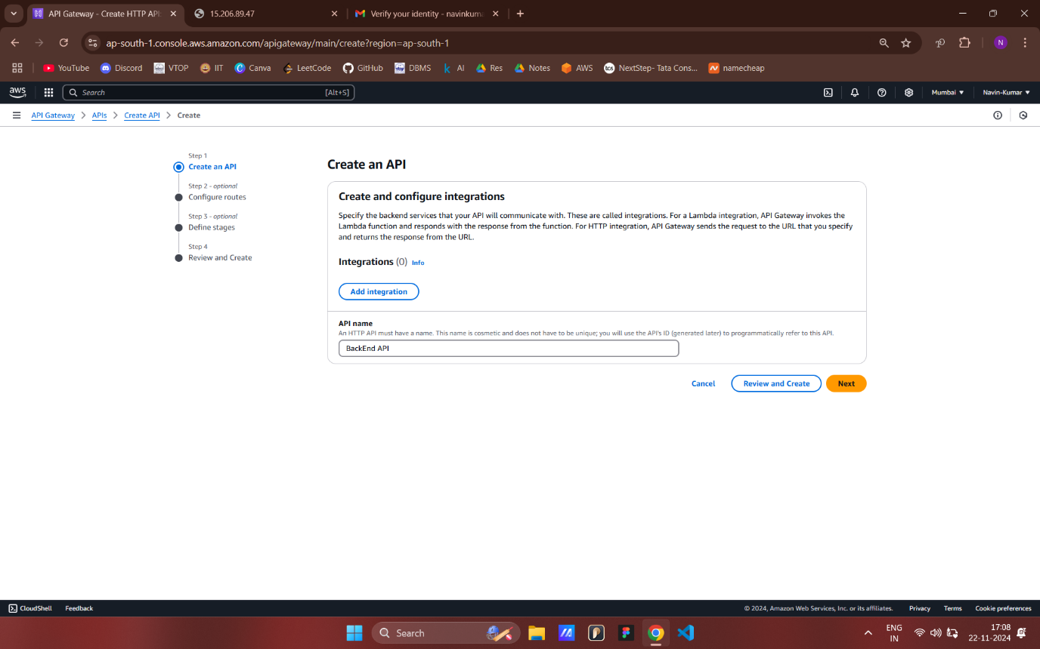

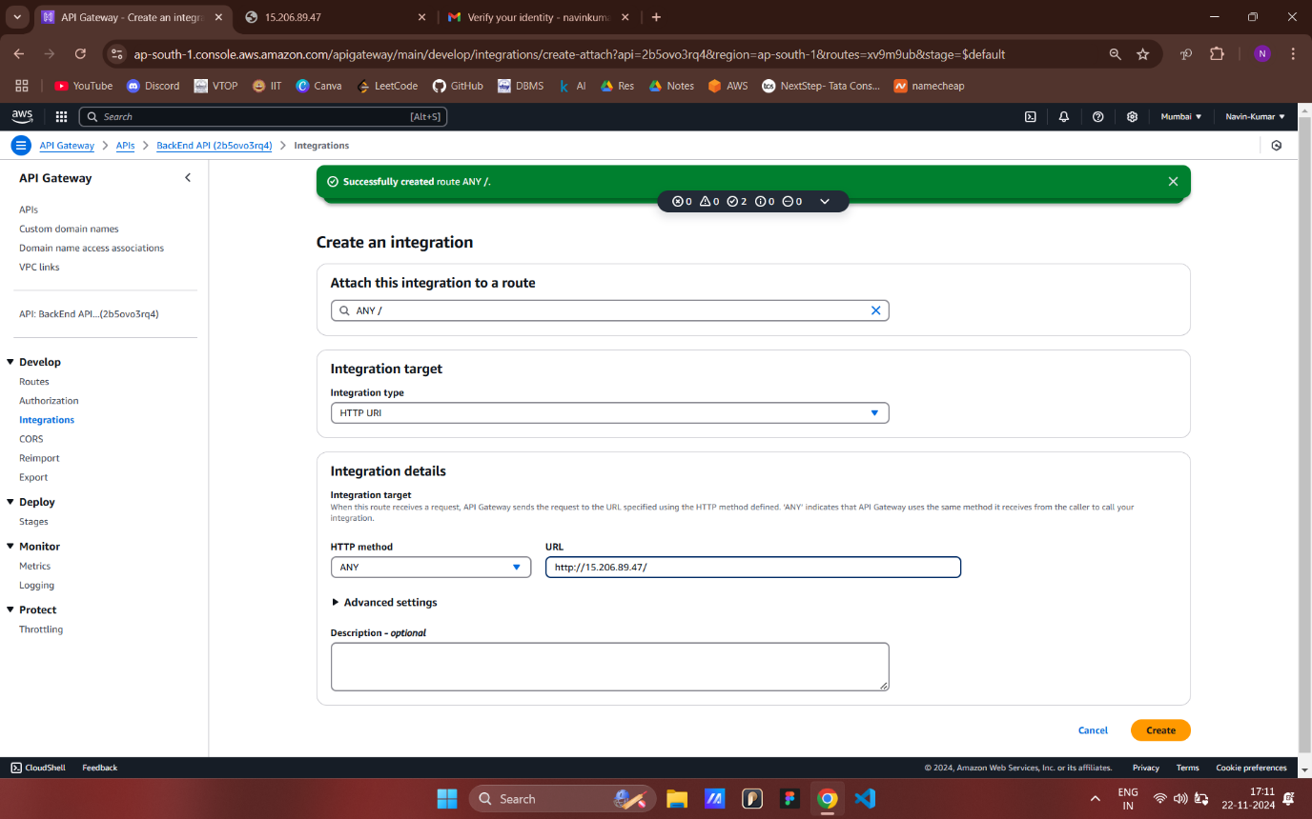

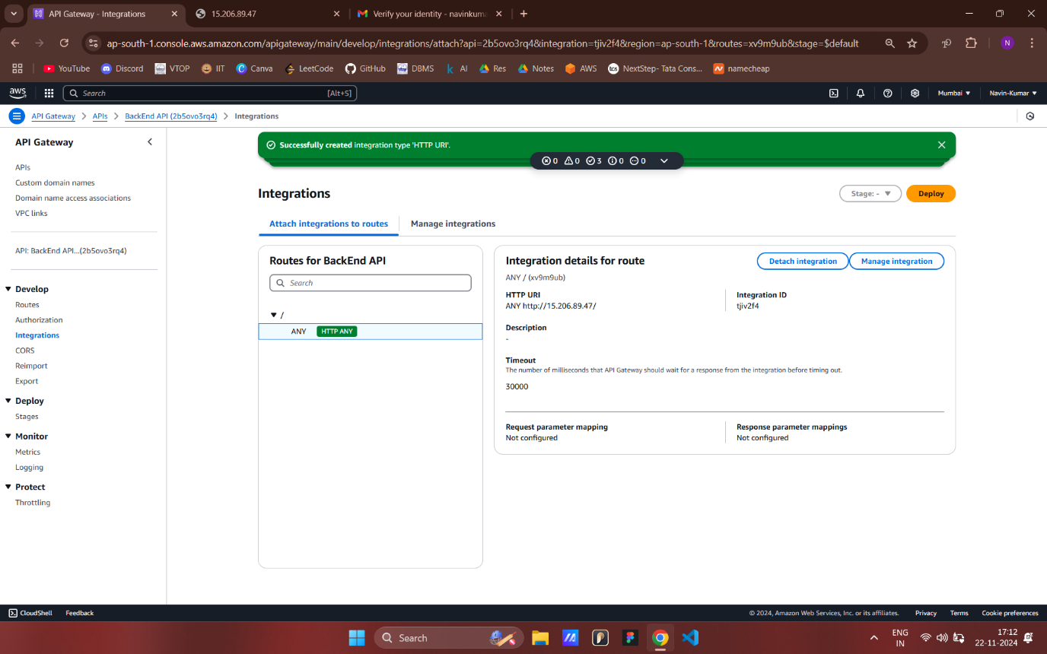

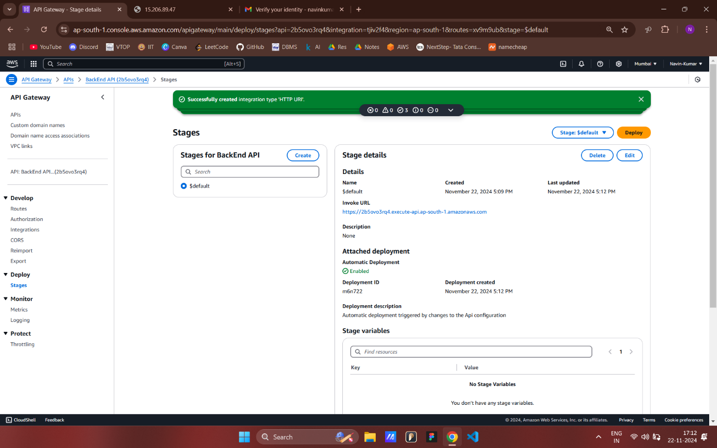

* Sagemaker

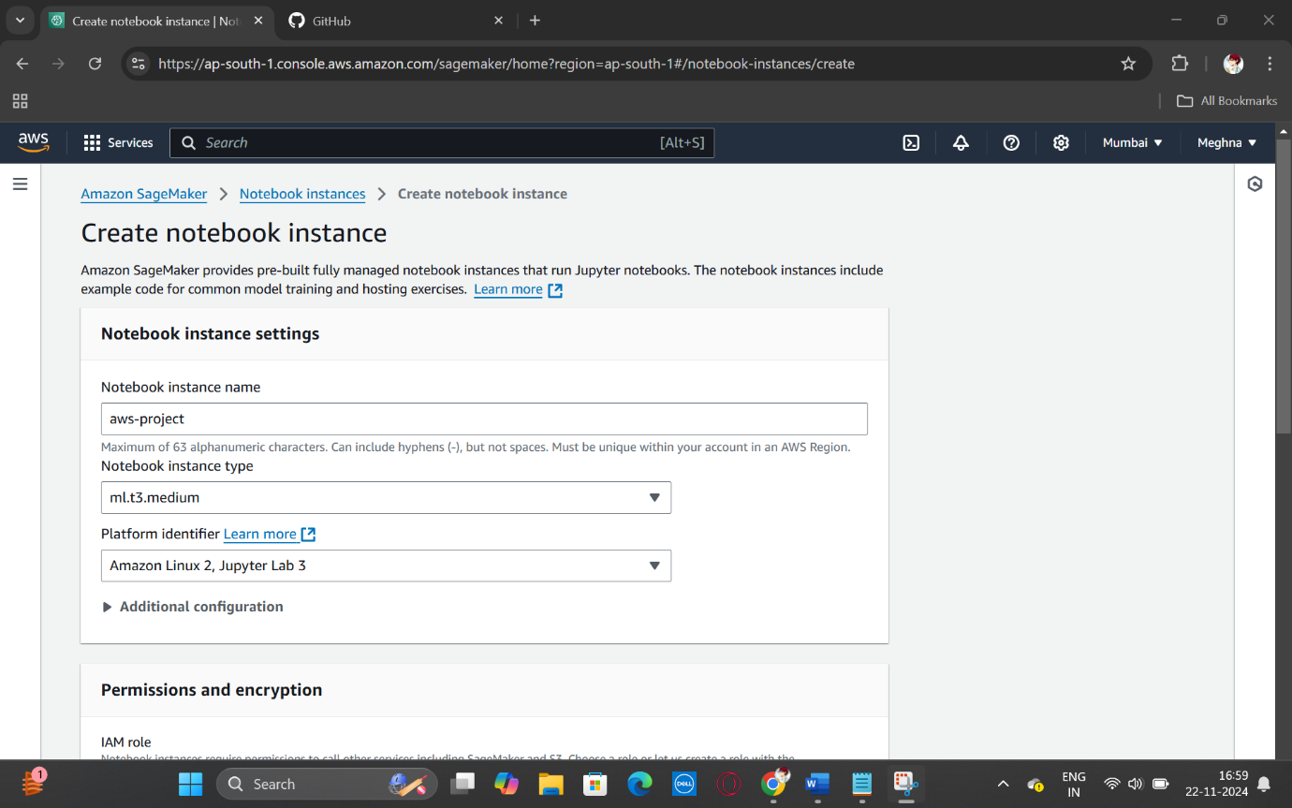

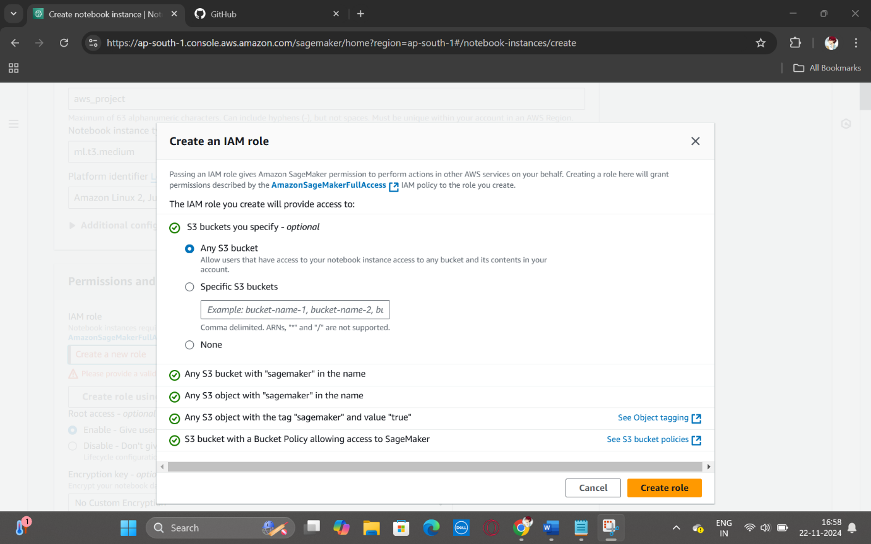

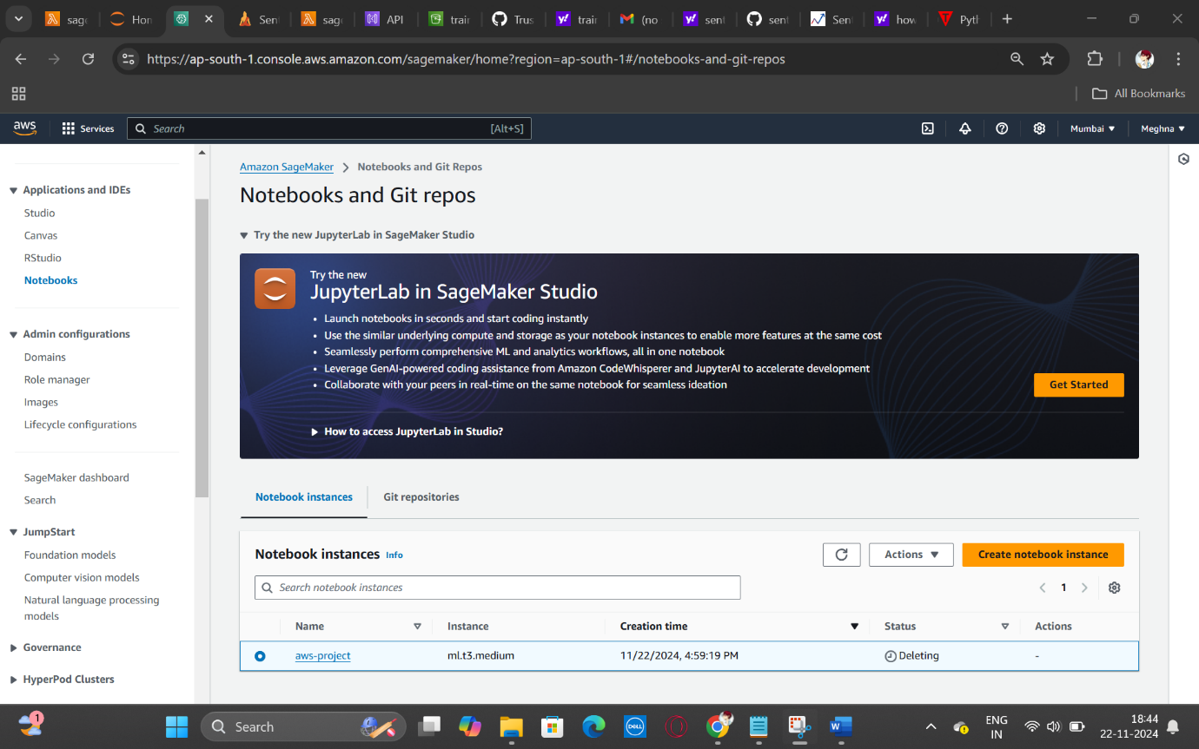

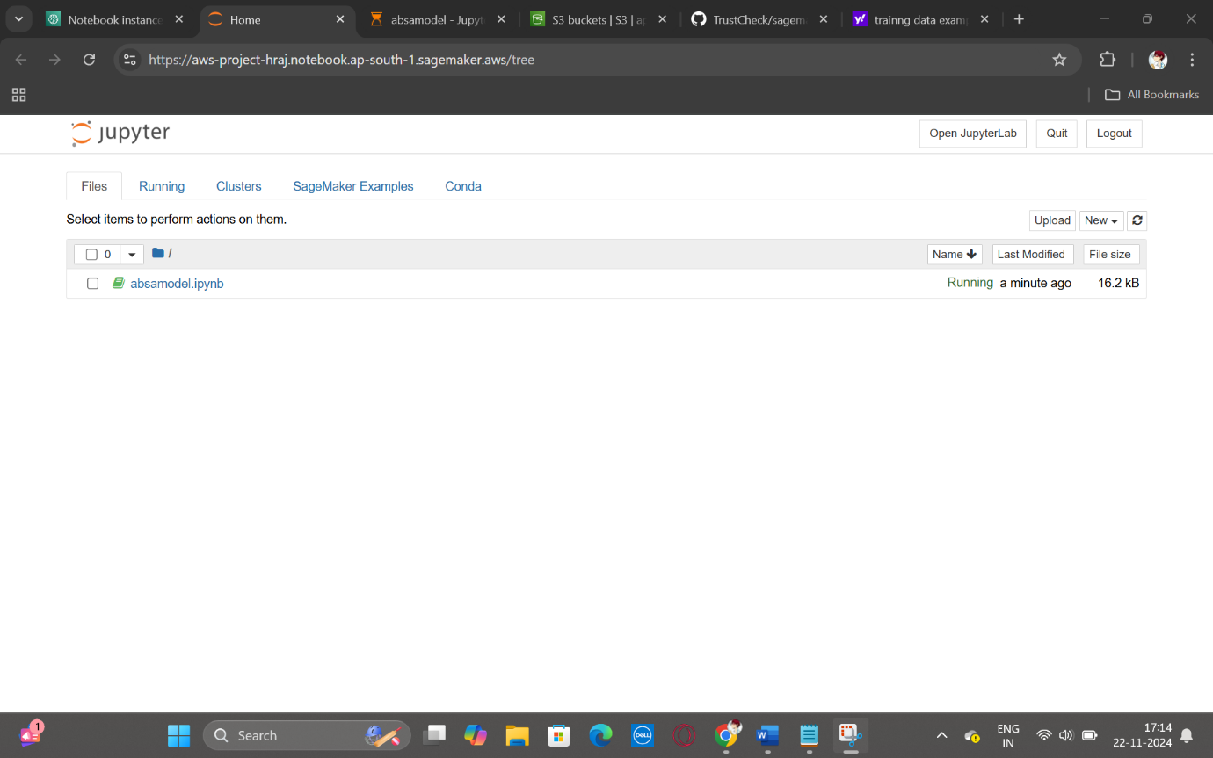

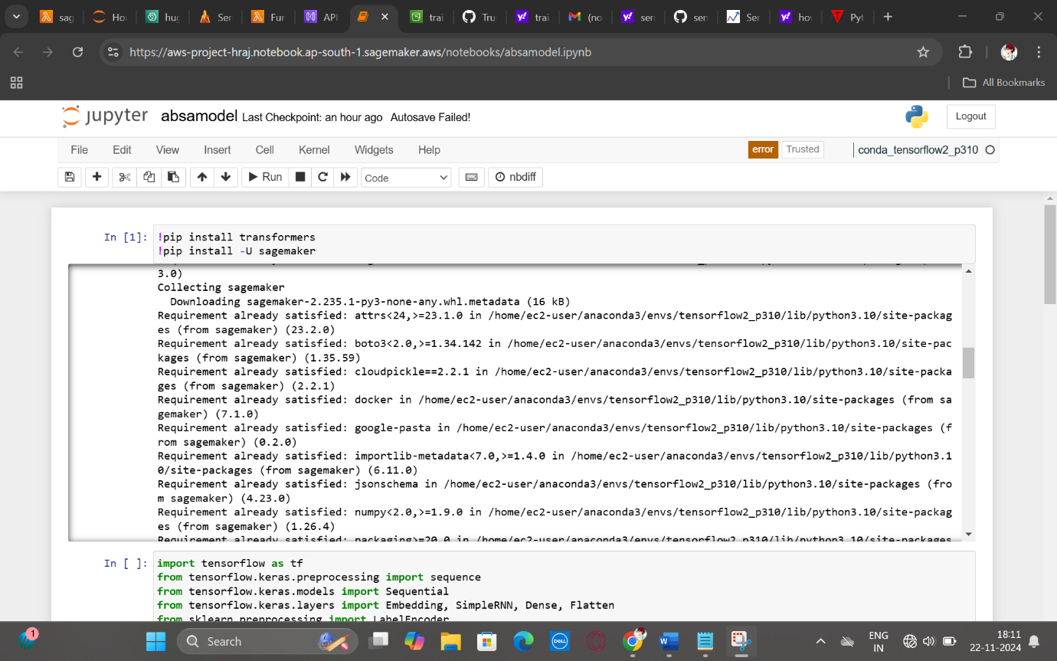

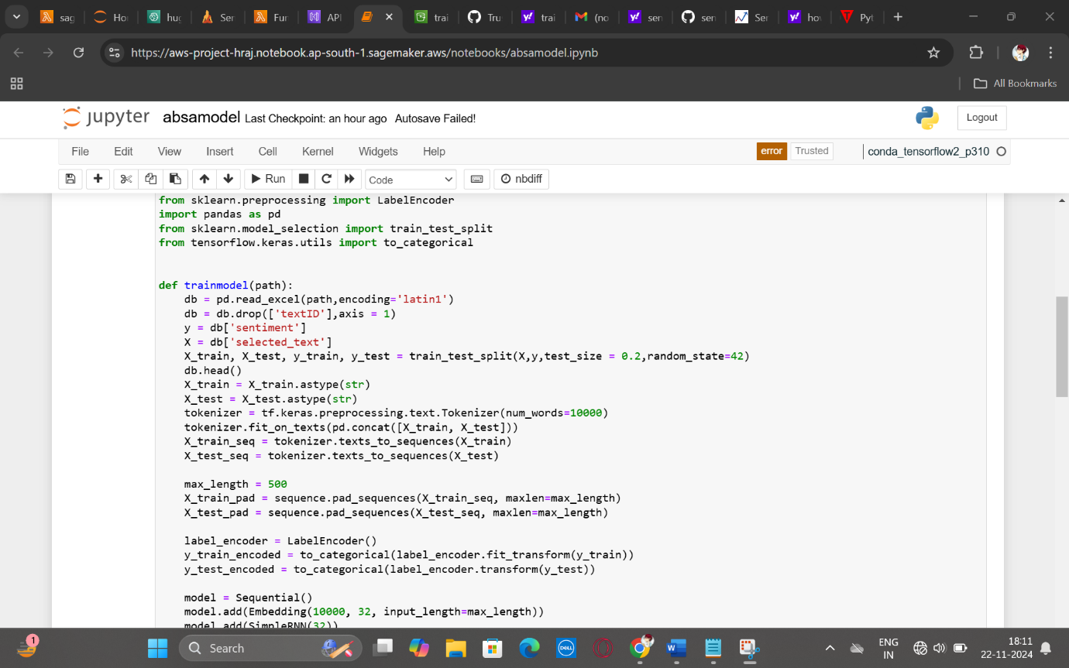

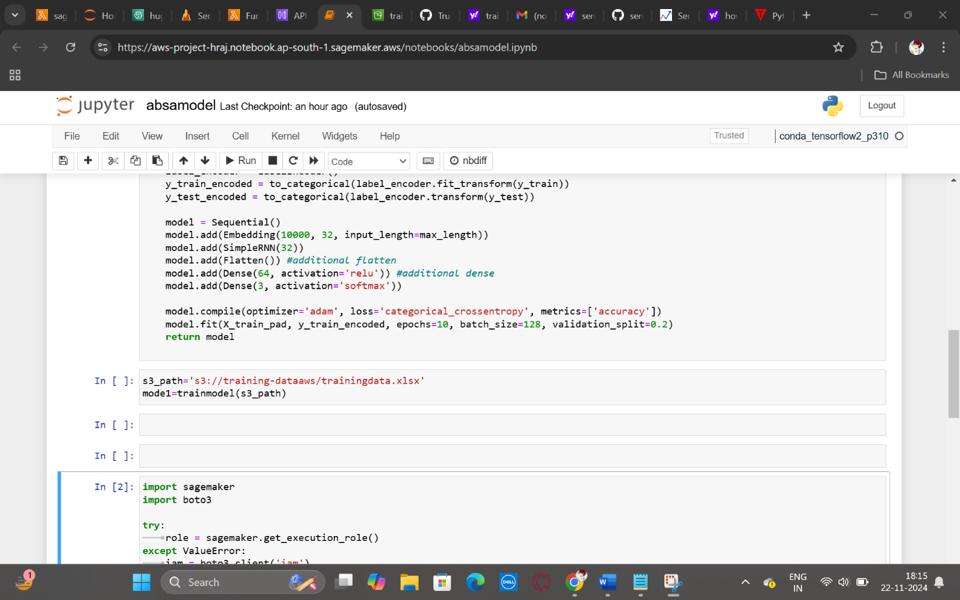

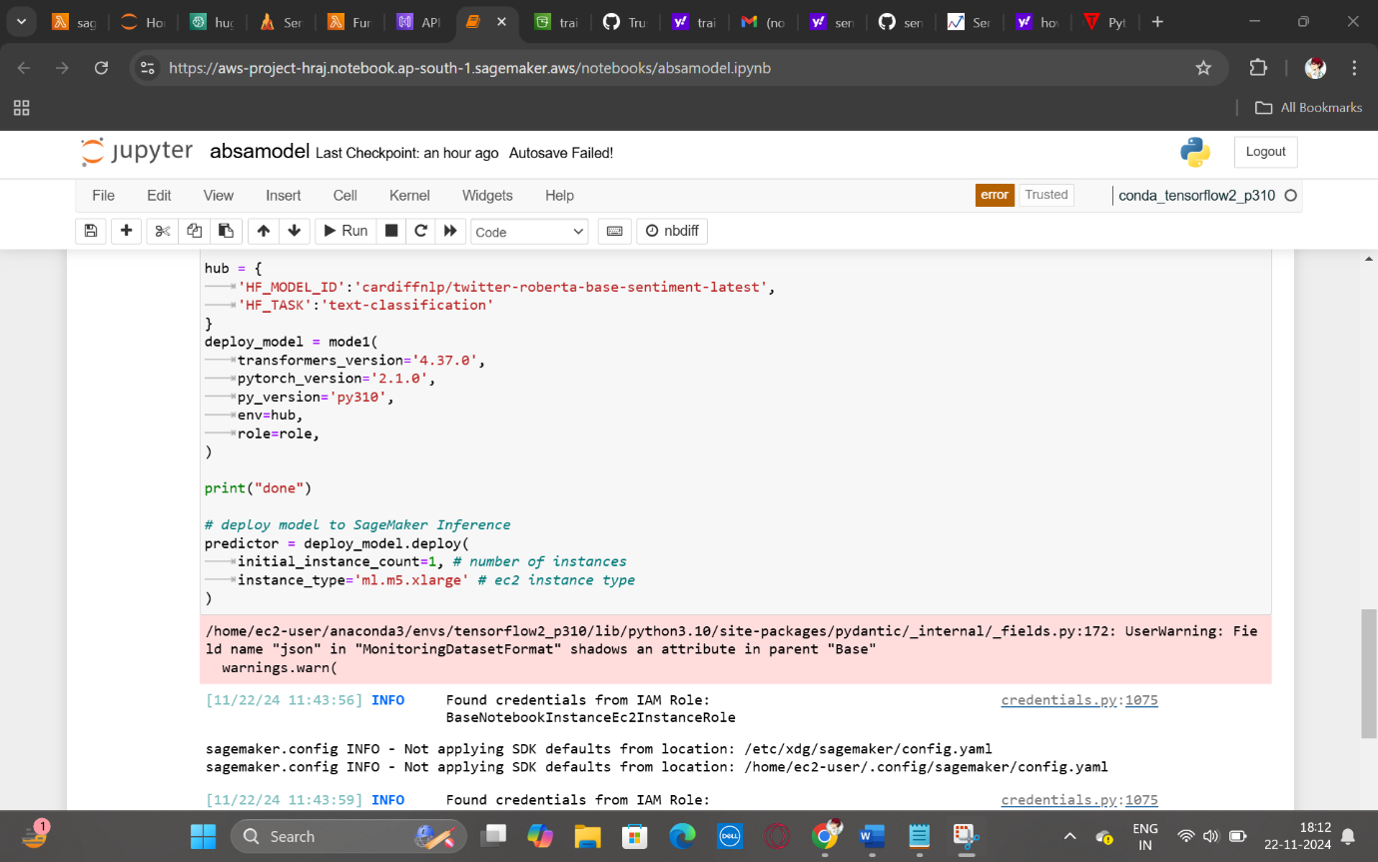

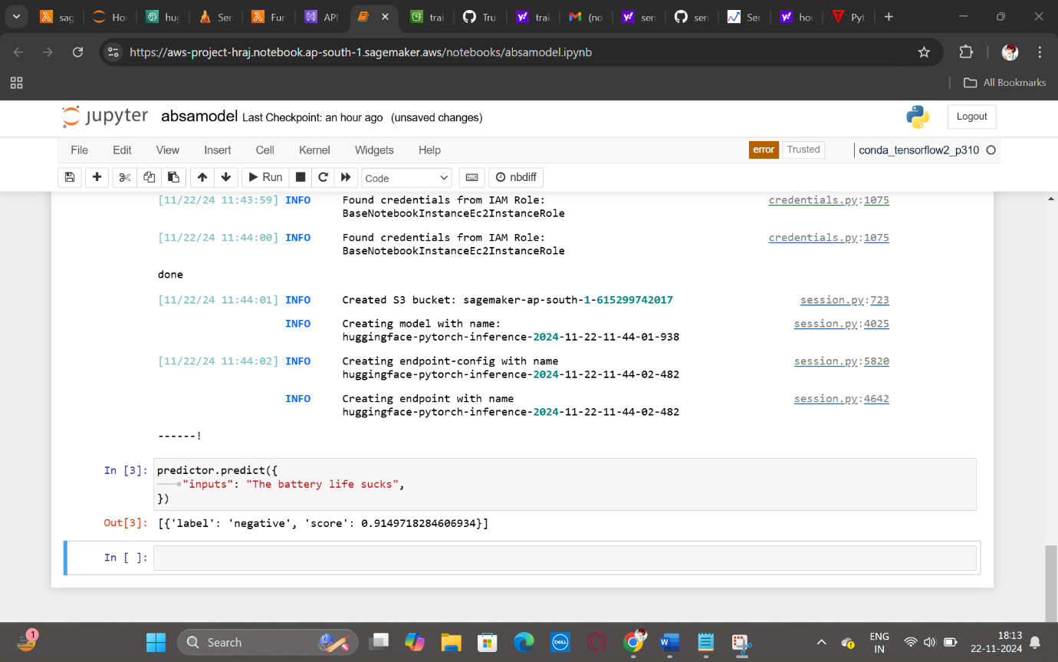

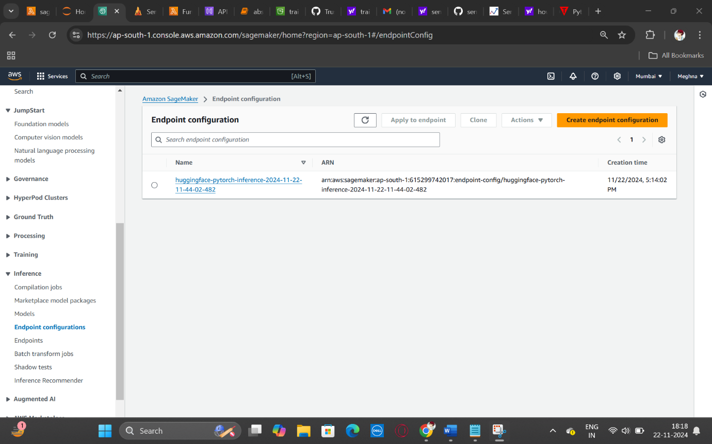

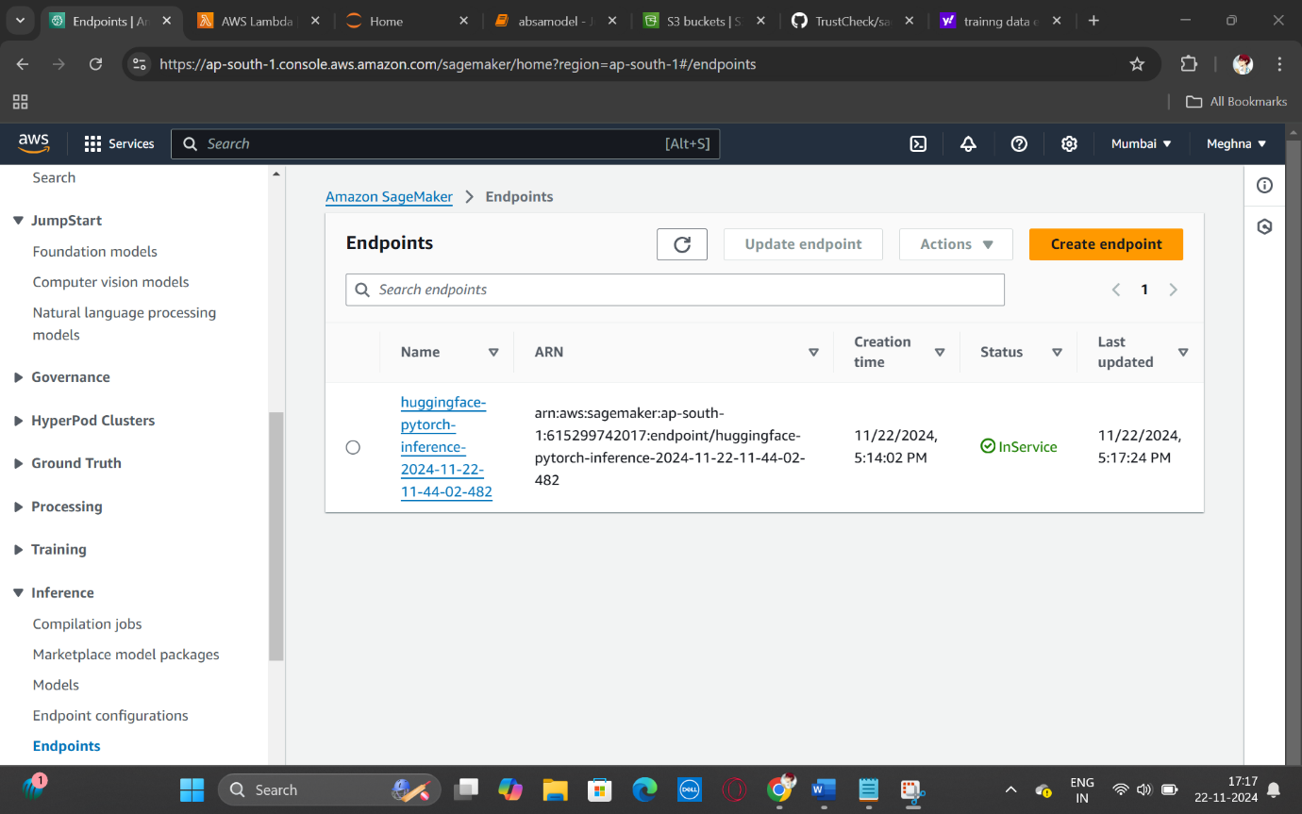

* S3

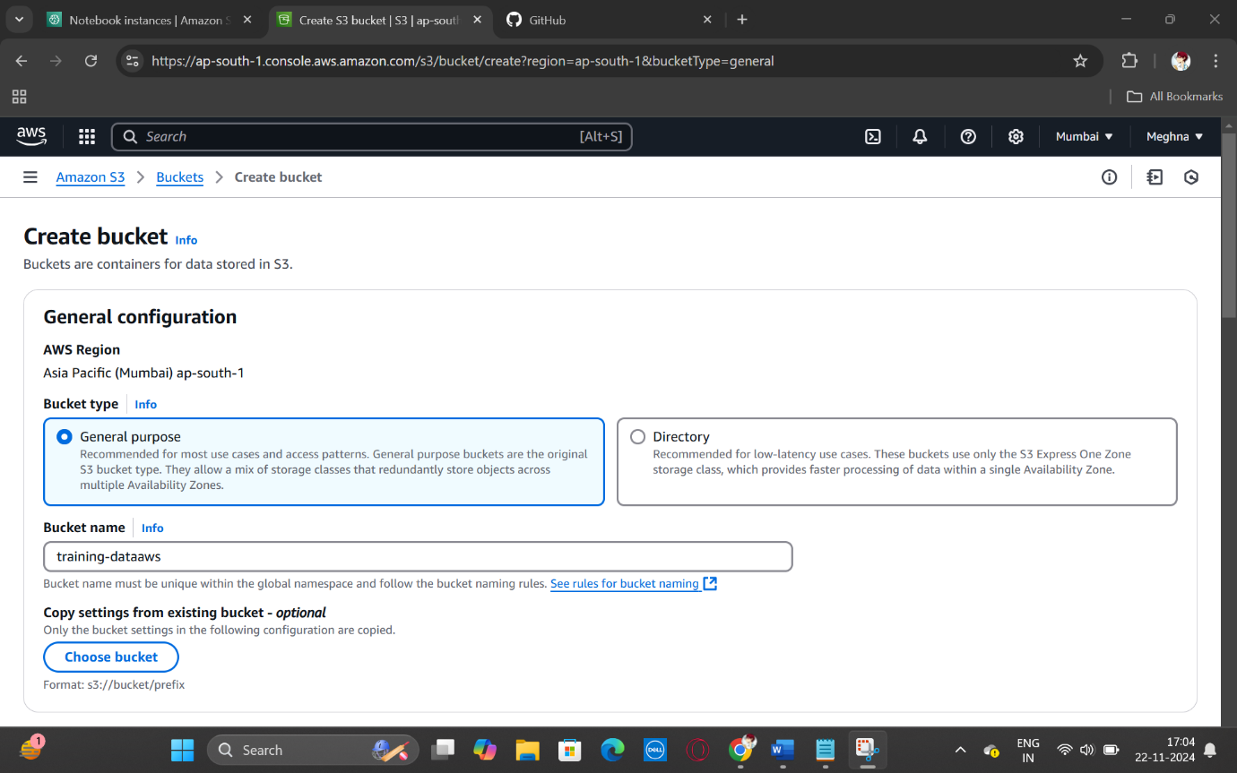

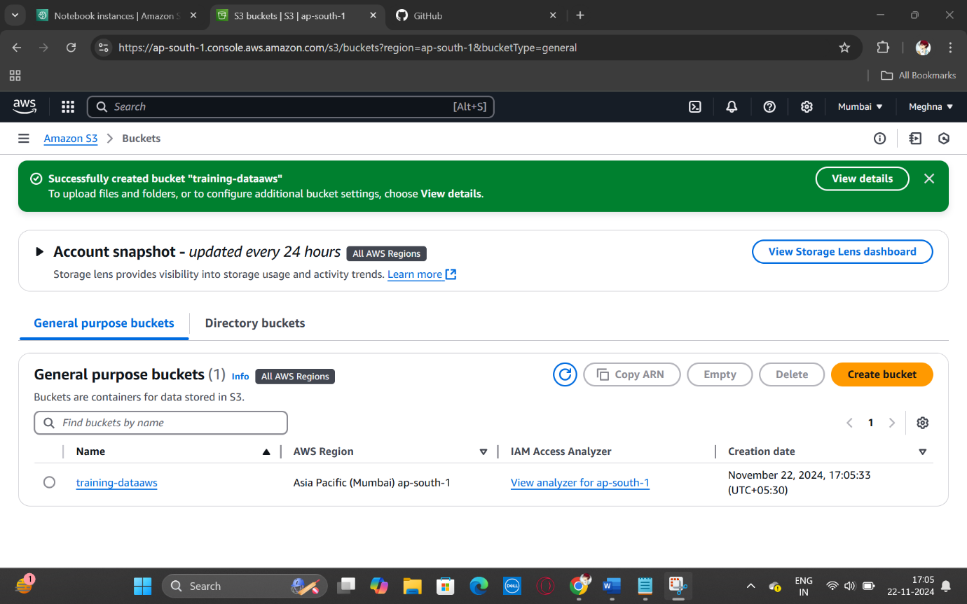

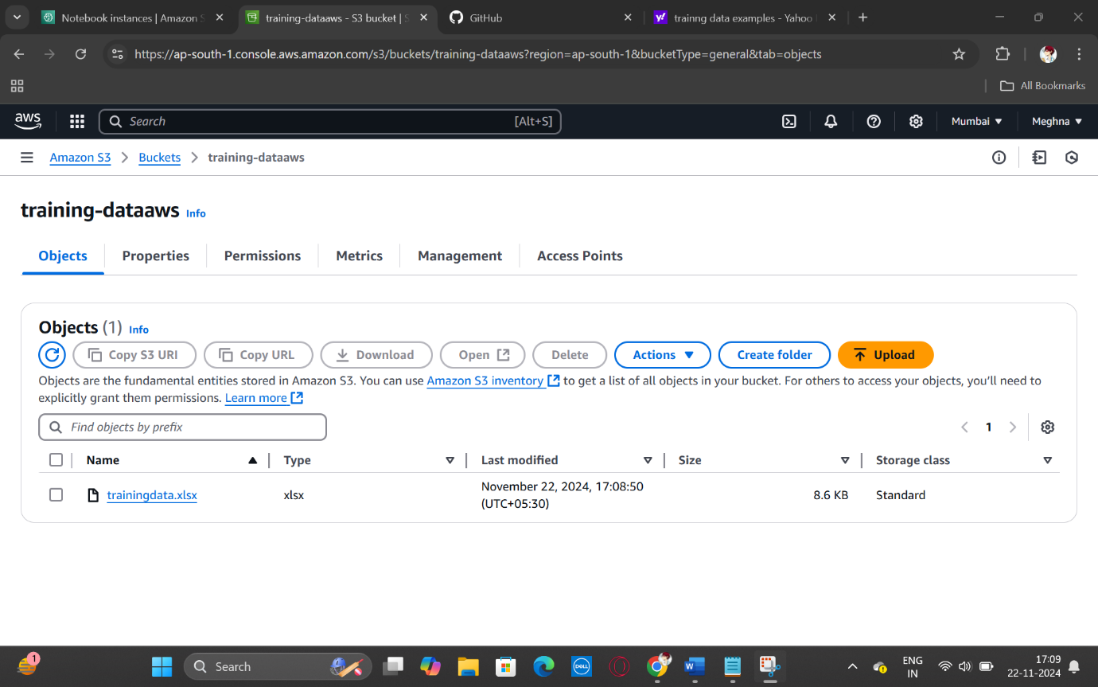

* Lambda

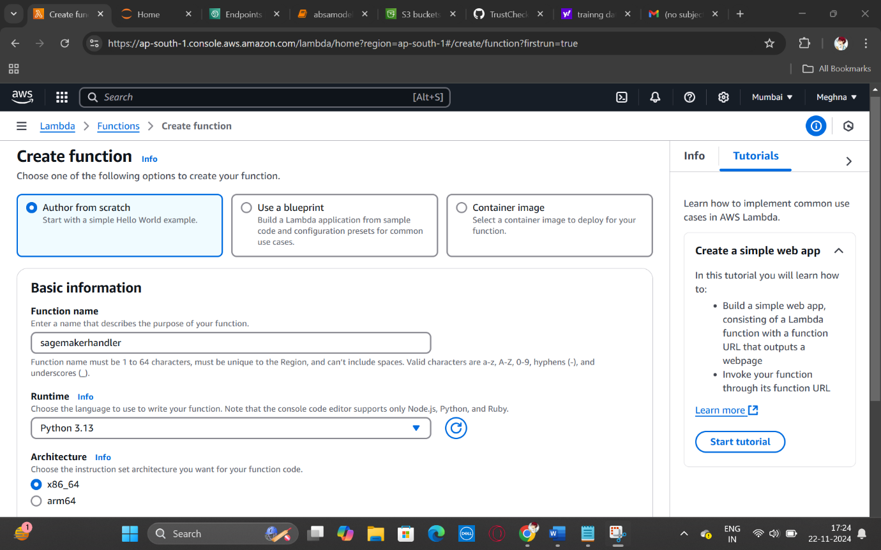

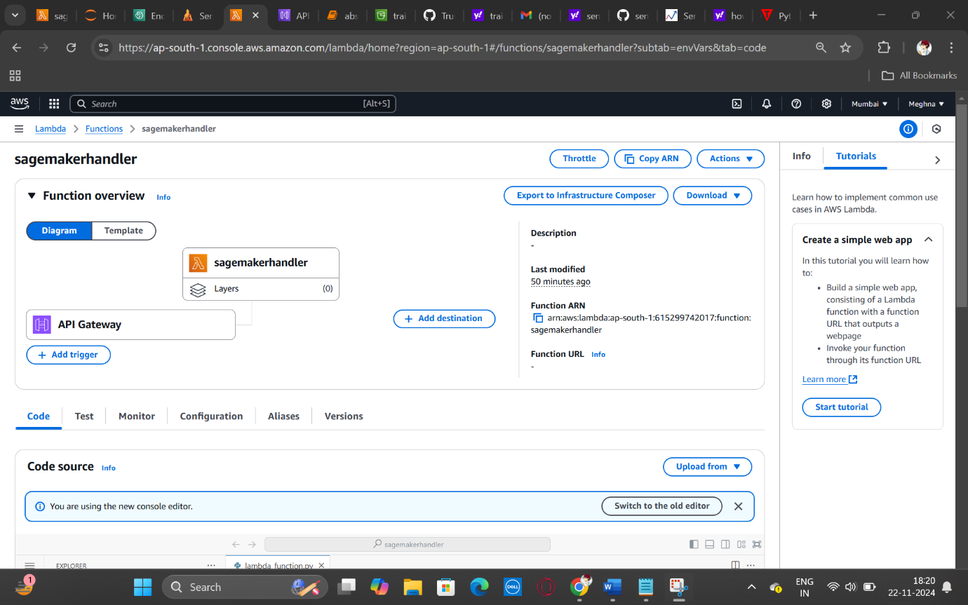

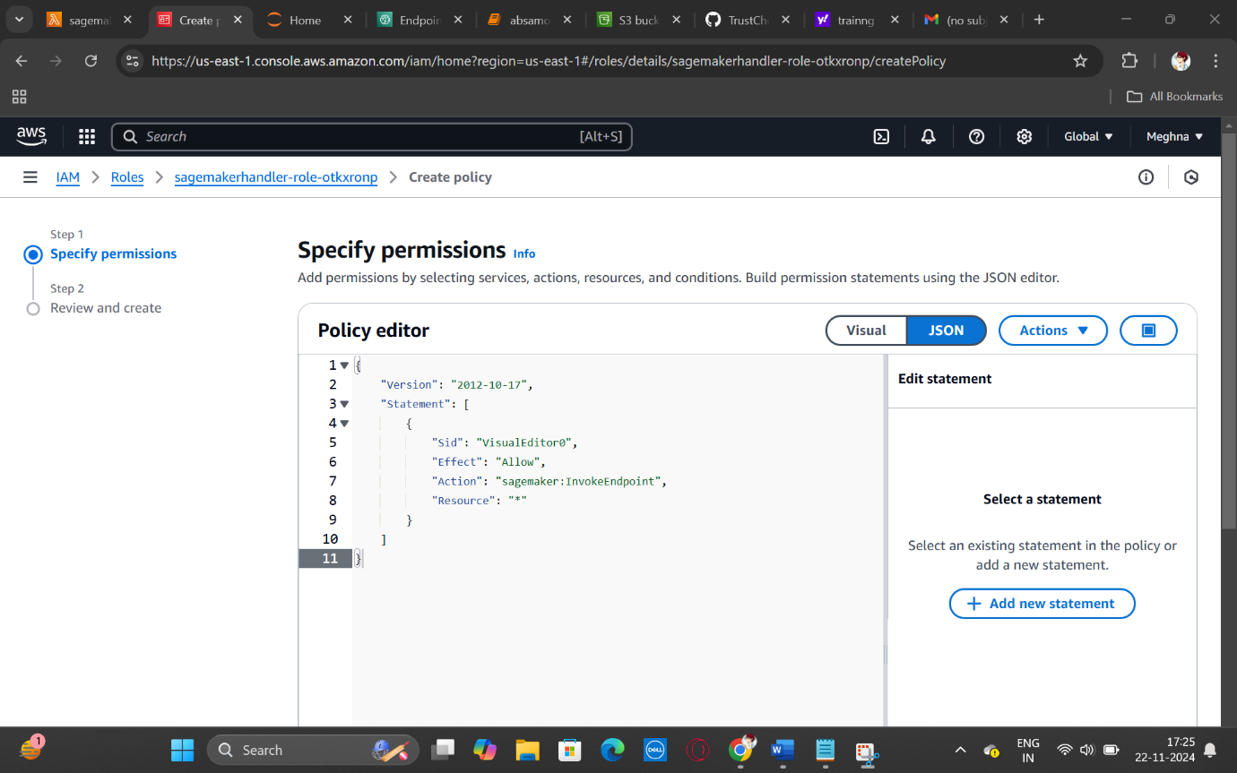

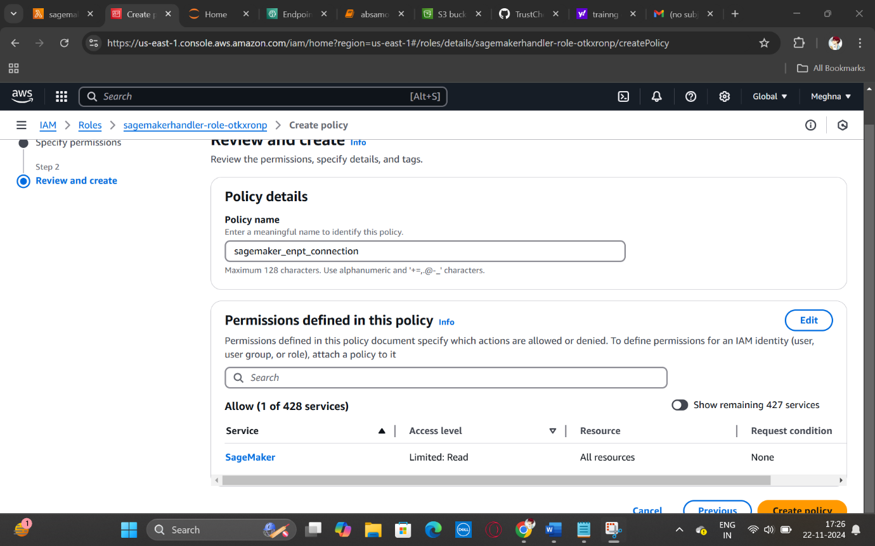

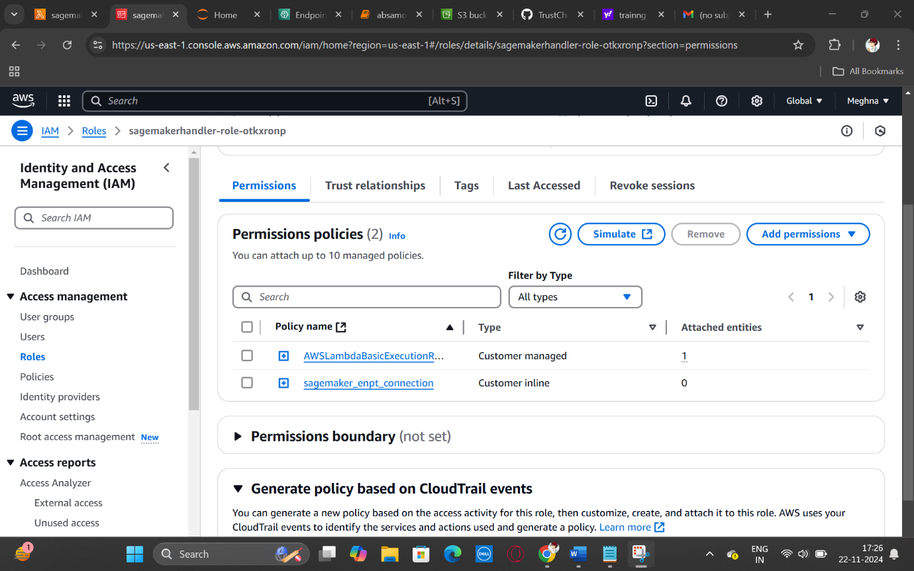

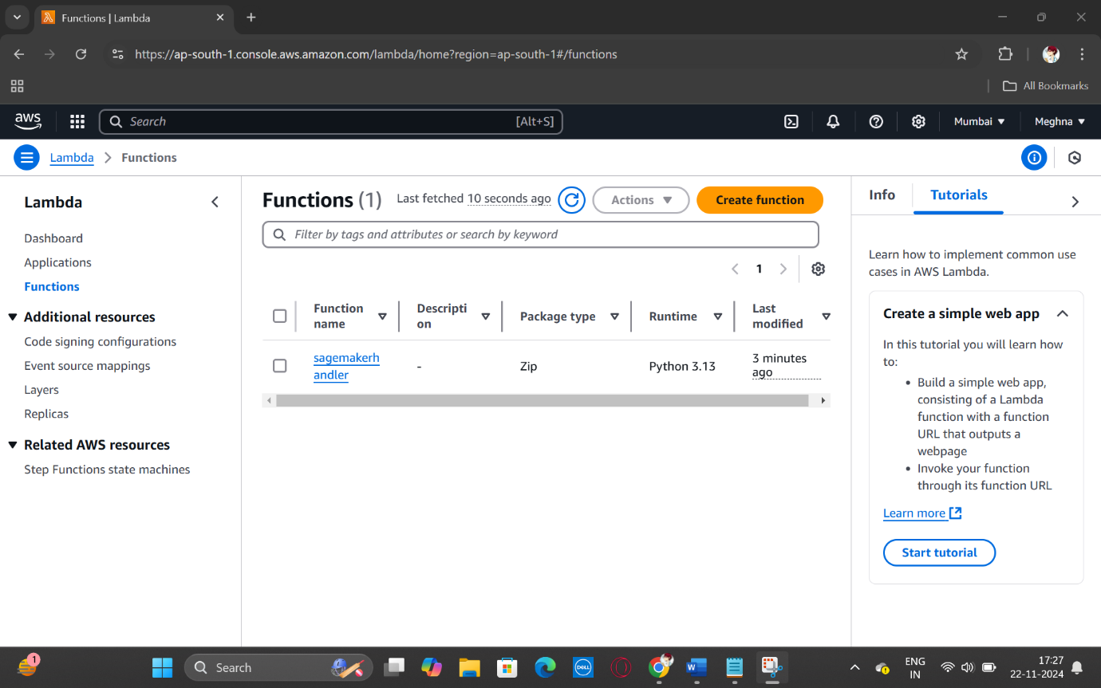

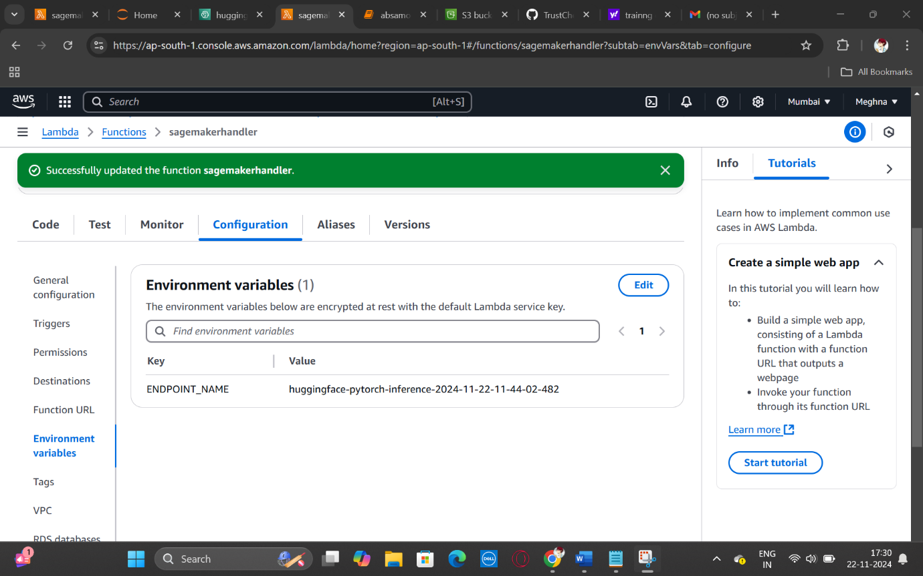

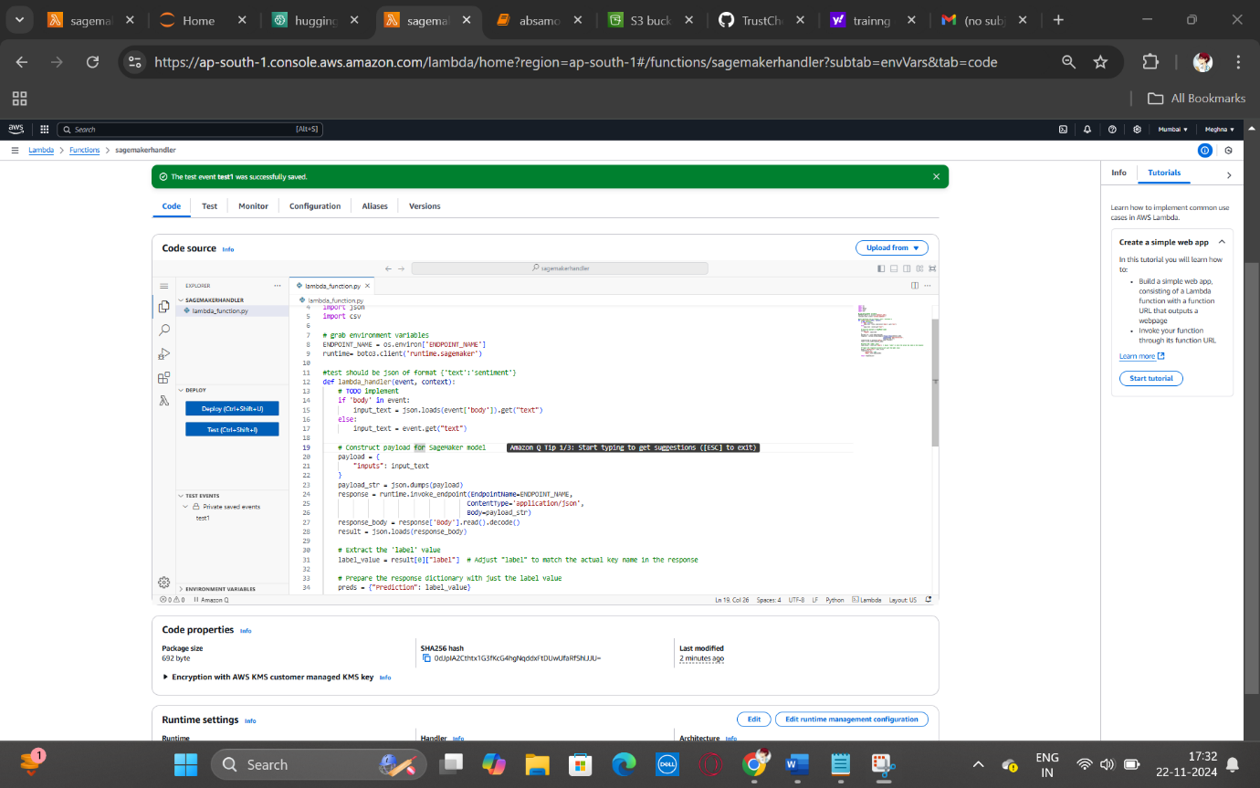

* Api gateway

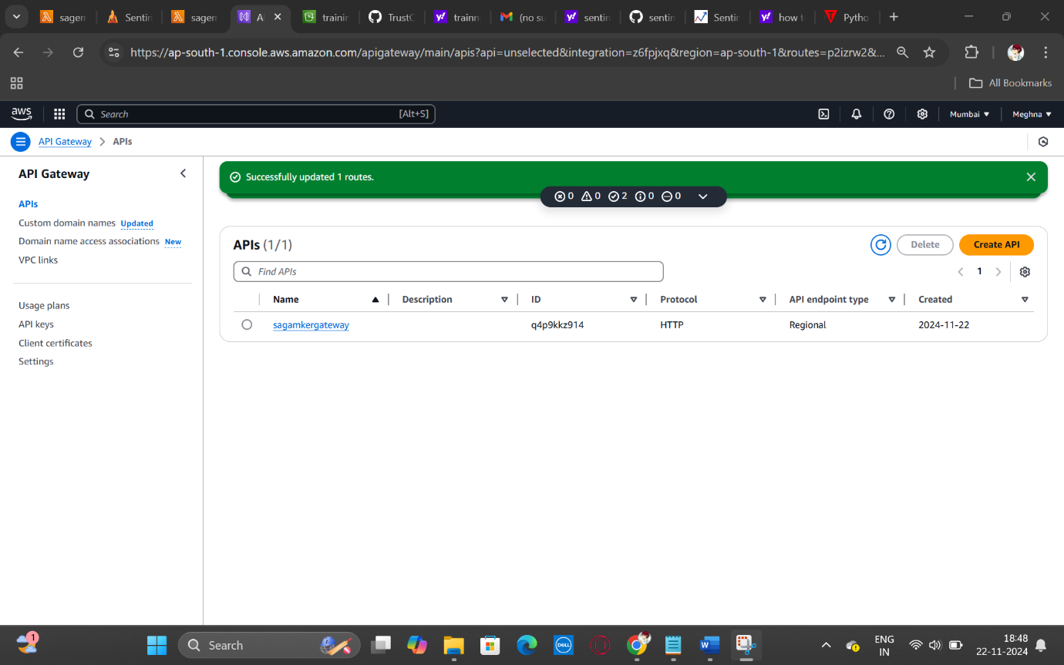

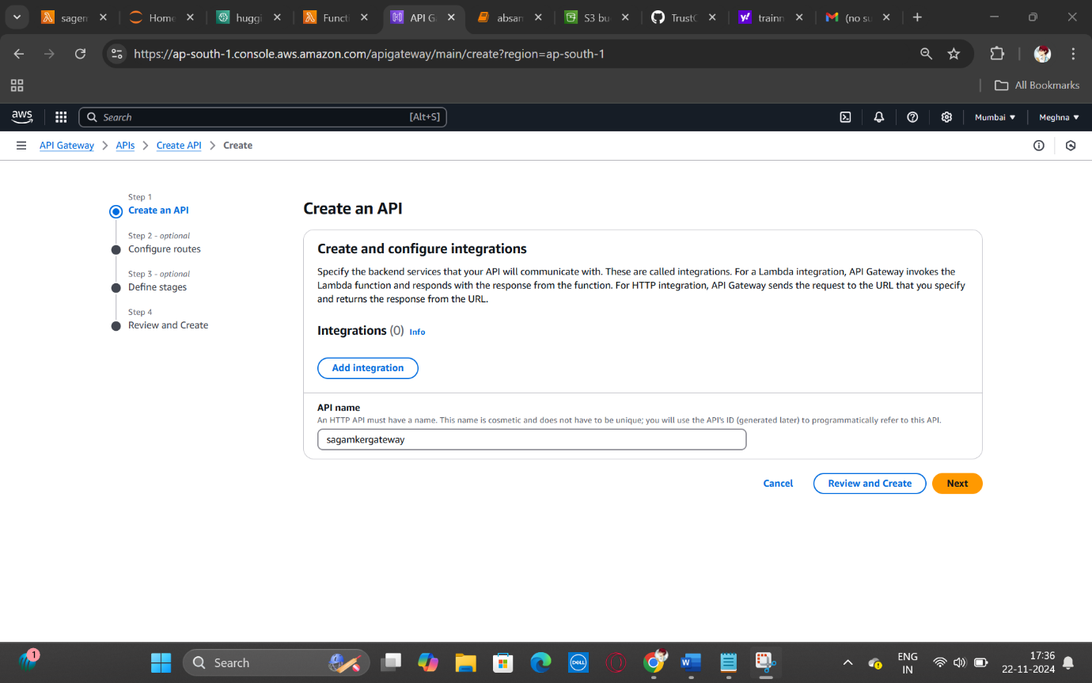

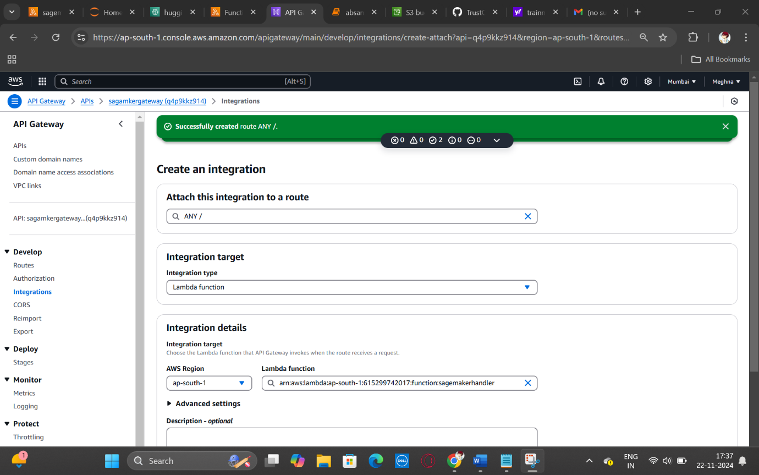

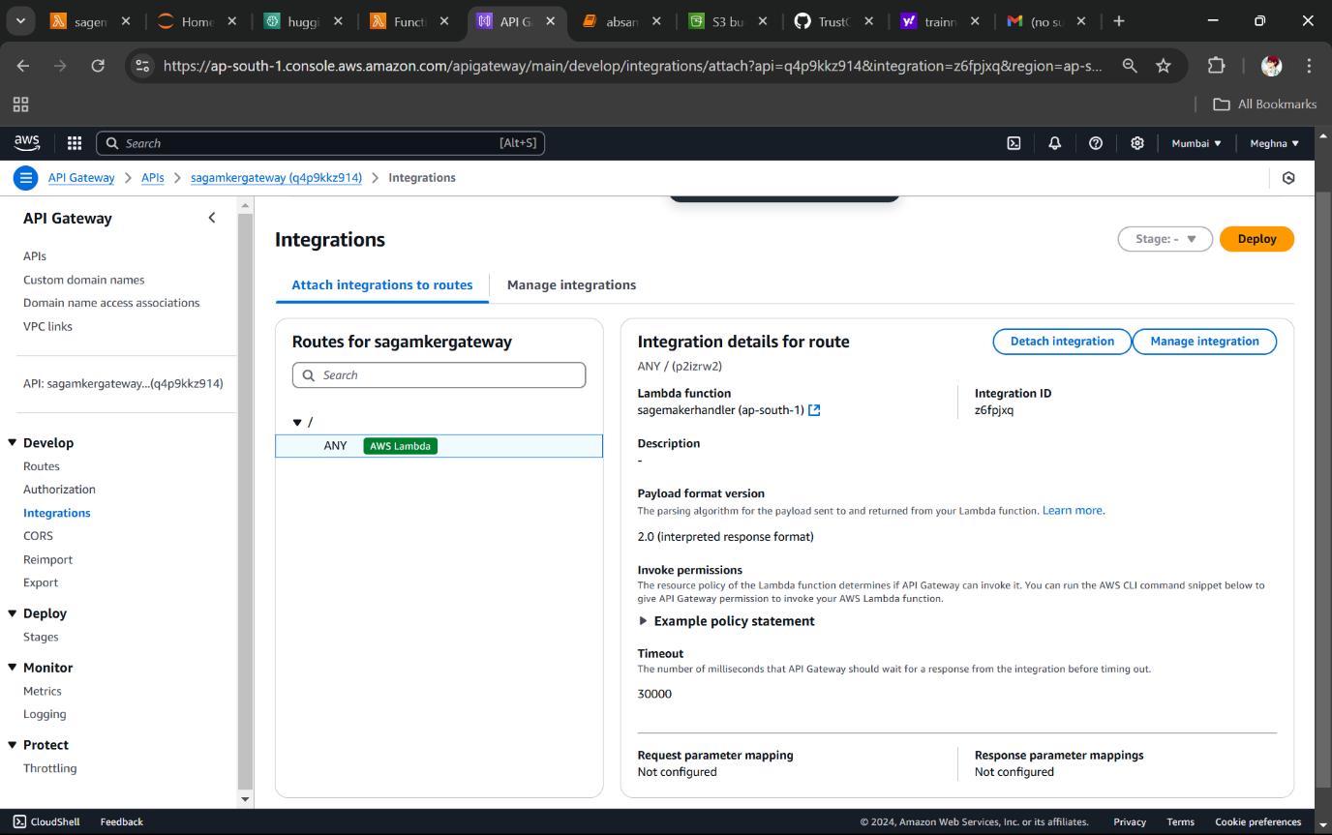

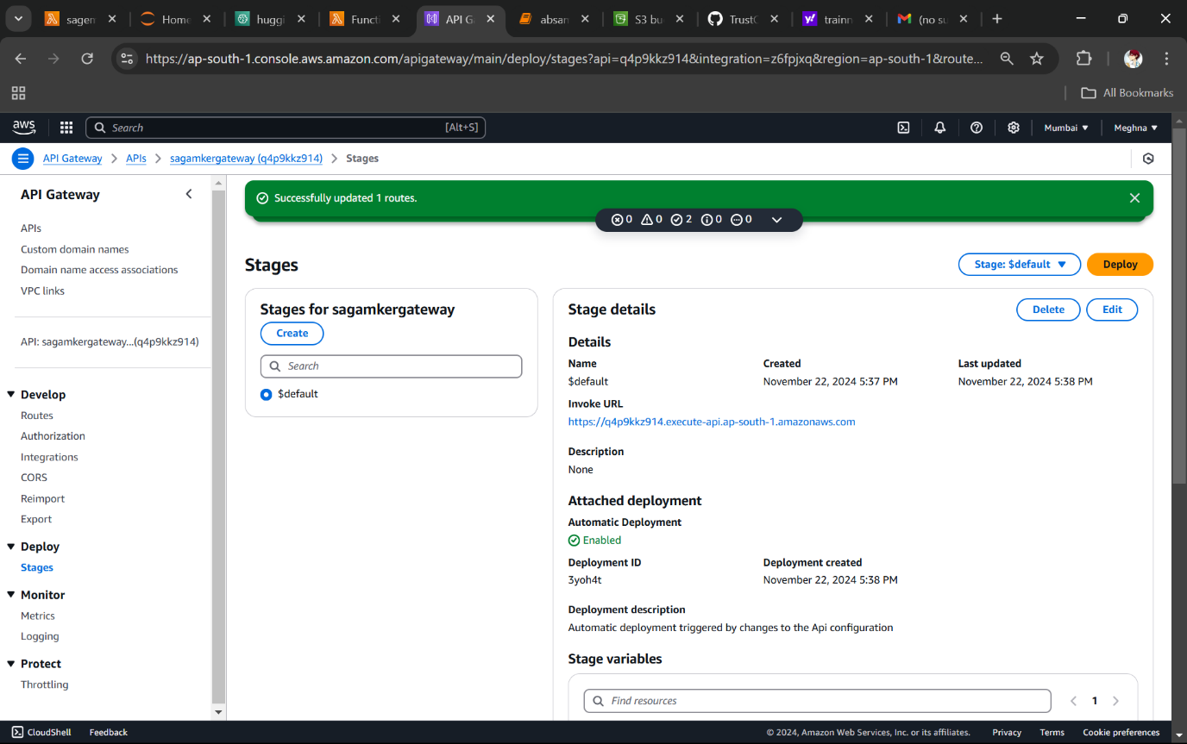

| Project Code

1. **Browser extension:**
   1. manifest.json

{

"manifest_version": 3,

"name": "Amazon Reviews Fetcher",

"version": "1.0",

"permissions": ["activeTab", "scripting","alarms"],

"action": {

"default_popup": "popup.html"

},

"content_scripts": [

{

"matches": ["<all_urls>"],

"js": ["content.js"]

}

],

"icons": {

"128": "128.png"

}

}

* 1. popup.js

document.getElementById('fetch-reviews').addEventListener('click', () => {

var aspect = document.getElementById("messageInput").value;

let mes = ""

if(aspect == ""){ mes = "alertMessage" }

else{ mes = aspect}

chrome.tabs.query({ active: true, currentWindow: true }, (tabs) => {

chrome.tabs.sendMessage(tabs[0].id, { message: mes });

});

chrome.runtime.onMessage.addListener((message, sender, sendResponse) => {

if (message.verdict) {

console.log("New message received: ", message.verdict);

document.getElementById("out").innerHTML = message.verdict;

}

});

});

* 1. popup.html

<!DOCTYPE html>

<html>

<head>

<title>Amazon Review Fetcher</title>

<style>

body{

display: flex;

width: 300px;

background-color: black;

flex-direction: column;

font-family: monospace;

color: aliceblue;

}

h1{

margin-top: 0;

text-align: center;

font-size: 2.5em;

border-bottom: 1px solid white;

padding-top: 10px;

padding-bottom: 12px;

}

#asp{

font-size: 2em;

}

#fetch-reviews{

padding: 10px;

margin:auto;

width: 50%;

font-family: monospace;

background-color: black;

color: aliceblue;

box-shadow: 5px 5px aliceblue;

}

#fetch-reviews:active {

box-shadow: 0 0 #666;

transform: translateY(5px);

transform: translateX(5px);

}

#butdiv{

margin-top: 16px;

display: flex;

}

input{

width: 200px;

height: 30px;

background-color: black;

border: 1px white solid;

color: white;

border-radius: 2px;

font-family: monospace;

}

#verdict{

background-color: aliceblue;

color: black;

margin-top: 14px;

padding: 12px;

padding-left: 5px;

padding-right: 5px;

line-height: 1.5;

}

#ver{

background-color: aliceblue;

font-size: 1.8em;

font-weight: bold;

}

#out{

font-size: 1.5em;

}

</style>

</head>

<body>

<h1>TRUSTCHECK</h1>

<div>

<label for="messageInput" id = "asp">Aspect: </label>

<input type="text" id="messageInput" placeholder="Enter your Aspect" />

</div>

<div id = "butdiv">

<button id="fetch-reviews">Fetch Reviews</button>

</div>

<div id = "verdict">

<span id = "ver">Vedict: </span>

<span id = "out"></span>

</div>

<script src="popup.js"></script>

</body>

</html>

* 1. content.js

import {

SecretsManagerClient,

GetSecretValueCommand,

} from "@aws-sdk/client-secrets-manager";

async function getReview(){

const reviews = [];

while (true) {

document.querySelectorAll('.review').forEach(reviewElement => {

const reviewText = reviewElement.querySelector('.review-text').innerText;

reviews.push(reviewText);

});

const nextButtonContainer = document.querySelector('li.a-last');

if (nextButtonContainer && nextButtonContainer.classList.contains('a-disabled')) {

break;

} else if (nextButtonContainer) {

nextButtonContainer.querySelector('a').click();

console.log("click")

await new Promise(resolve => setTimeout(resolve, 2000));

} else {

console.log("Next button not found.");

break;

}

}

console.log("All Reviews Collected:", reviews);

return reviews

}

chrome.runtime.onMessage.addListener(async (request, sender, sendResponse) => {

if(request.message === "alertMessage") {

alert("Enter a aspect")

}

else{

let arr = await getReview()

const myHeaders = new Headers();

myHeaders.append("Content-Type", "application/json");

const raw = JSON.stringify({

sentance: arr,

aspect: request.message

});

const requestOptions = {

method: "POST",

headers: myHeaders,

body: raw,

redirect: "follow",

};

const secret_name = "SECRET_KEY";

const client = new SecretsManagerClient({

region: "ap-south-1",

});

let response;

try {

response = await client.send(

new GetSecretValueCommand({

SecretId: secret_name,

VersionStage: "AWSCURRENT",

})

);

} catch (error) { throw error;}

const secret = response.SecretString;

fetch(secret, requestOptions)

.then((response) => response.text())

.then((result) => {

console.log(result)

chrome.runtime.sendMessage({ verdict: JSON.parse(result).verdict });

})

.catch((error) => {

console.error(error)

chrome.runtime.sendMessage({ verdict: "failure" });

});

}

});

1. **Node JS Server**
2. App.js

const http = require('node:http');

const express = require('express');

const cors = require('cors');

var emojiStrip = require('emoji-strip');

const LanguageDetect = require('languagedetect');

const langDetect = new LanguageDetect();

langDetect.setLanguageType('iso2');

const port = 80;

const app = express();

app.use(cors());

app.use(express.json());

app.post('/', (req, res) => {

let sen = req.body.sentance

let asp = req.body.aspect

sen = sen.map(sentence => emojiStrip(sentence.replace(/\n/g, ' ')));

console.log(sen);

const myHeaders = new Headers();

myHeaders.append("Content-Type", "application/json");

const raw = JSON.stringify({

text: sen[0]

});

const requestOptions = {

method: "POST",

headers: myHeaders,

body: raw,

redirect: "follow",

};

let result = {}

fetch("https://q4p9kkz914.execute-api.ap-south-1.amazonaws.com", requestOptions)

.then((response) => response.text())

.then((result) => {

console.log(result)

final = JSON.parse(result)

result = {

verdict: final.Prediction,

};

res.json(result);

})

.catch((error) => {

console.error(error)

final = "error"

result = {

verdict: final,

};

res.json(result);

});

});

app.listen(port, () => {

console.log(`Server running on port ${port}`);

});

1. **Sagemaker**

!pip install transformers

!pip install -U sagemaker

import tensorflow as tf

from tensorflow.keras.preprocessing import sequence

from tensorflow.keras.models import Sequential

from tensorflow.keras.layers import Embedding, SimpleRNN, Dense, Flatten

from sklearn.preprocessing import LabelEncoder

import pandas as pd

from sklearn.model_selection import train_test_split

from tensorflow.keras.utils import to_categorical

def trainmodel(path):

db = pd.read_excel(path,encoding='latin1')

db = db.drop(['textID'],axis = 1)

y = db['sentiment']

X = db['selected_text']

X_train, X_test, y_train, y_test = train_test_split(X,y,test_size = 0.2,random_state=42)

db.head()

X_train = X_train.astype(str)

X_test = X_test.astype(str)

tokenizer = tf.keras.preprocessing.text.Tokenizer(num_words=10000)

tokenizer.fit_on_texts(pd.concat([X_train, X_test]))

X_train_seq = tokenizer.texts_to_sequences(X_train)

X_test_seq = tokenizer.texts_to_sequences(X_test)

max_length = 500

X_train_pad = sequence.pad_sequences(X_train_seq, maxlen=max_length)

X_test_pad = sequence.pad_sequences(X_test_seq, maxlen=max_length)

label_encoder = LabelEncoder()

y_train_encoded = to_categorical(label_encoder.fit_transform(y_train))

y_test_encoded = to_categorical(label_encoder.transform(y_test))

model = Sequential()

model.add(Embedding(10000, 32, input_length=max_length))

model.add(SimpleRNN(32))

model.add(Flatten()) #additional flatten

model.add(Dense(64, activation='relu')) #additional dense

model.add(Dense(3, activation='softmax'))

model.compile(optimizer='adam', loss='categorical_crossentropy', metrics=['accuracy'])

model.fit(X_train_pad, y_train_encoded, epochs=10, batch_size=128, validation_split=0.2)

return model

s3_path=’s3://training-dataaws.trainingdata.xlsv’

model=trainmodel(path)

import sagemaker

import boto3

try:

role = sagemaker.get_execution_role()

except ValueError:

iam = boto3.client('iam')

role = iam.get_role(RoleName='sagemaker_execution_role')['Role']['Arn']

hub = {

'HF_MODEL_ID':'cardiffnlp/twitter-roberta-base-sentiment-latest',

'HF_TASK':'text-classification'

}

# create Hugging Face Model Class

deploy_model = model(

transformers_version='4.37.0',

pytorch_version='2.1.0',

py_version='py310',

env=hub,

role=role,

)

print("done")

# deploy model to SageMaker Inference

predictor =deploy_model.deploy(

initial_instance_count=1, # number of instances

instance_type='ml.m5.xlarge' # ec2 instance type

)

predictor.predict({

"inputs": "The battery life sucks",

})

1. **Lambda**

result = json.loads(response_body)

# Extract the 'label' value

label_value = result[0]["label"] # Adjust "label" to match the actual key name in the response

# Prepare the response dictionary with just the label value

preds = {"Prediction": label_value}

response_dict = {

"statusCode": 200,

"body": json.dumps(preds)

}

return response_dict

#permission

{

"Version": "2012-10-17",

"Statement": [

{

"Sid": "VisualEditor0",

"Effect": "Allow",

"Action": "sagemaker:InvokeEndpoint",

"Resource": "*"

}

]

}

| References

<https://docs.aws.amazon.com/ec2/>

<https://docs.aws.amazon.com/lambda/>

<https://docs.aws.amazon.com/s3/>

<https://docs.aws.amazon.com/sagemaker/>

<https://docs.aws.amazon.com/apigateway/>

<https://docs.aws.amazon.com/secretsmanager/>

<https://docs.aws.amazon.com/iam/>

<https://paperswithcode.com/paper/effective-lstms-for-target-dependent>

<https://paperswithcode.com/paper/attention-based-lstm-for-aspect-level>